ASCPi MLS High-Yield Study Notes
Nov 10, 2026 · @Henry Kyei Baffour
Seven sections, one per exam content area, in order of exam weight. Checked topic by topic against ASCP's MLS(ASCPi) content outline. Written from standard MLS knowledge, so verify exact numbers against your Bottom Line and BOC Study Guide.

1. Hematology and Hemostasis (17-22%)
If you only remember 8 things
- Low MCV (microcytic) = iron deficiency, thalassemia, chronic disease, sideroblastic, lead. High MCV (macrocytic) = B12 or folate deficiency, liver disease, alcohol.
- The reticulocyte count shows what the marrow is doing: high = marrow responding (bleeding, hemolysis); low = marrow not producing.
- Spherocytes with a positive DAT = autoimmune hemolysis. Spherocytes with a negative DAT = hereditary spherocytosis.
- Schistocytes (fragments) = DIC, TTP, HUS, or a mechanical heart valve.
- Auer rods = AML. t(15;17) = APL. t(9;22) = CML.
- PT checks the extrinsic pathway (factor VII) and warfarin. aPTT checks the intrinsic pathway and heparin.
- DIC: PT and aPTT prolonged, platelets low, fibrinogen low, D-dimer high.
- Coagulation tubes: light blue citrate, filled to the line (9 parts blood to 1 part citrate).
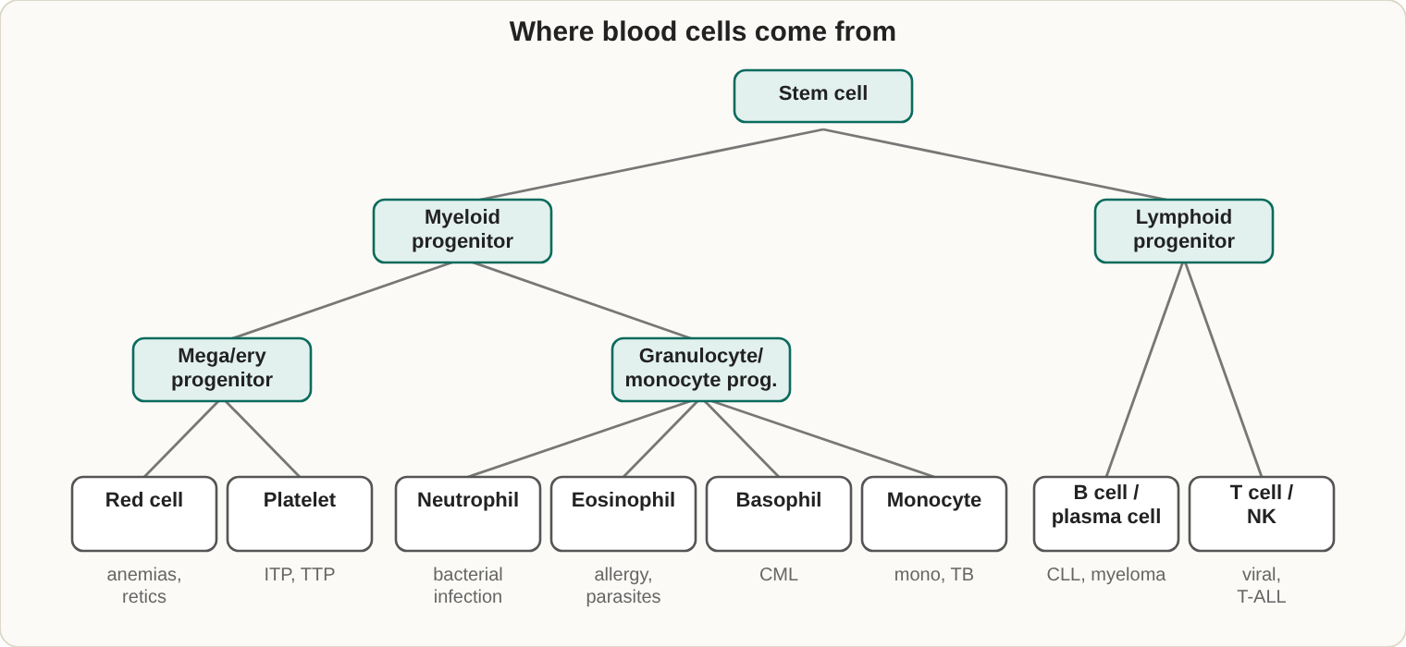
Blood cell lineages. The cell type that is raised often points to the disease.
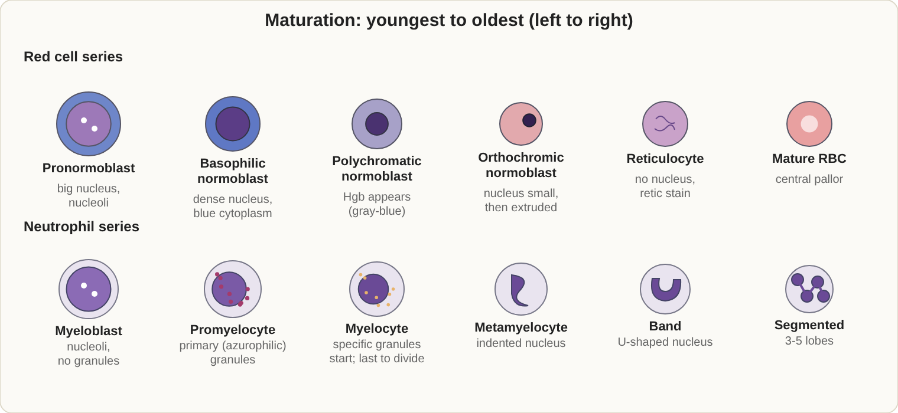
Maturation series. Cells shrink, nuclei condense, and cytoplasm turns from blue to pink as they mature.

Cell maturation (youngest to oldest)
- Red cell: pronormoblast, basophilic normoblast, polychromatic normoblast, orthochromic normoblast, reticulocyte, mature RBC.
- Neutrophil: myeloblast, promyelocyte, myelocyte, metamyelocyte, band, segmented neutrophil. Specific granules first appear at the myelocyte.
- Platelet: megakaryoblast, promegakaryocyte, megakaryocyte, platelets.
- Megaloblastic change means a large cell with a young, open nucleus and a mature cytoplasm (nuclear-cytoplasmic asynchrony).

Formulas worth memorizing
Test | Formula | Normal
MCV (fL) | Hct x 10 / RBC (millions) | 80-100
MCH (pg) | Hgb x 10 / RBC | 27-33
MCHC (g/dL) | Hgb x 100 / Hct | 32-36
Corrected WBC | WBC x 100 / (100 + nRBC per 100 WBC)
Reticulocyte % | retics counted / 1000 RBC x 100 | 0.5-2.5%
Corrected retic | retic % x (patient Hct / 45)
Example: Hct 30%, RBC 4.0 million gives MCV = 30 x 10 / 4.0 = 75 fL (microcytic).
Rule of three: Hgb x 3 should equal the Hct within 3 points. If it does not, suspect lipemia, cold agglutinins or abnormal cells, and recheck.

Anemias
Group | Common causes | Clues
Microcytic, hypochromic | Iron deficiency, thalassemia, chronic disease, sideroblastic anemia, lead poisoning | See iron studies below; lead gives coarse basophilic stippling
Macrocytic | B12 or folate deficiency, liver disease, alcohol | Oval macrocytes, hypersegmented neutrophils (5 or more lobes), high LD
Normocytic | Acute blood loss, hemolysis, chronic disease, aplastic anemia, kidney disease | Use the retic count: high = loss or hemolysis, low = production problem
Iron studies at a glance
 | Serum iron | TIBC | Ferritin
Iron deficiency | Low | High | Low
Chronic disease | Low | Low | Normal or high
Thalassemia | Normal or high | Normal | Normal or high
Sideroblastic (ring sideroblasts) | High | Normal or low | High
- Pernicious anemia: antibodies to intrinsic factor (anti-IF), low B12.
- Aplastic anemia: low red cells, white cells and platelets (pancytopenia) with an empty marrow.

Hemolytic anemias: what you see, what to think
Finding on the smear or test | Think
Spherocytes, DAT positive | Autoimmune hemolytic anemia (warm = IgG; cold agglutinin disease = IgM anti-I)
Spherocytes, DAT negative, high MCHC, increased osmotic fragility | Hereditary spherocytosis
Schistocytes, low platelets | DIC, TTP, HUS
Sickle cells | Hemoglobin S; solubility test screens, electrophoresis confirms
Target cells | Hemoglobin C, thalassemia, liver disease, iron deficiency, after splenectomy
Heinz bodies, bite cells | G6PD deficiency (Heinz bodies show only with supravital stain)
Absent CD55 and CD59 on flow cytometry | PNH
Hemoglobin electrophoresis, alkaline pH 8.6. Runs from the origin toward the anode. Farthest: A, then F, then S, then C (C, E, A2 and O sit together closest to the origin). Memory trick: "A Fast Silly Cat." Acid gel pH 6.2 separates C from E and S from D and G.
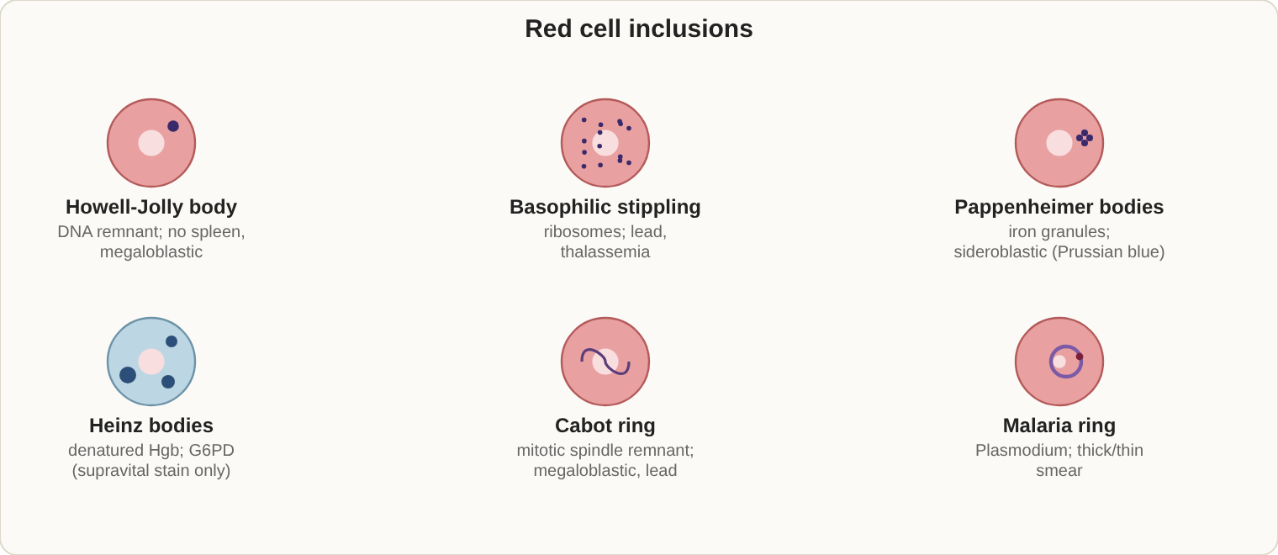
Red cell inclusions and what they point to.

Red cell inclusions
Inclusion | What it is | Seen in | Stain
Howell-Jolly body | DNA remnant | Asplenia, megaloblastic | Wright
Basophilic stippling | Ribosome RNA | Lead, thalassemia | Wright
Pappenheimer bodies | Iron granules | Sideroblastic anemia | Prussian blue
Heinz bodies | Denatured hemoglobin | G6PD deficiency | Supravital
Cabot rings | Spindle remnant | Severe anemia | Wright
HbH inclusions | Beta-chain tetramers | Alpha thalassemia | Brilliant cresyl blue
Reticulocytes | RNA | Regeneration | New methylene blue
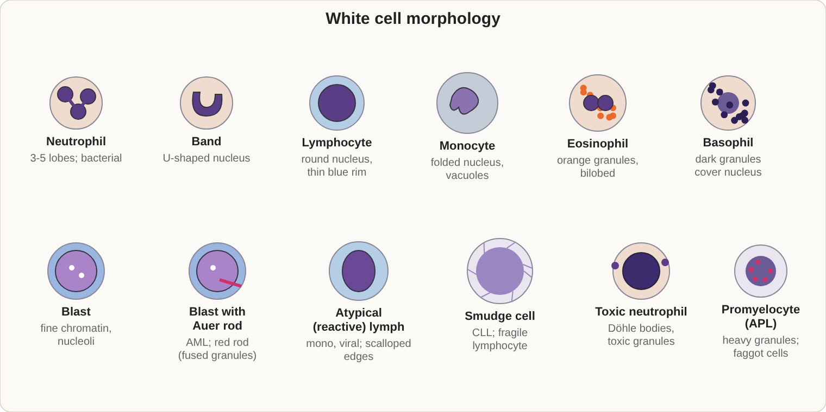
Normal white cells and the blasts you must recognize.

White cells and leukemias
- A left shift (more bands) with toxic granulation, Dohle bodies or vacuoles points to bacterial infection.
- Pelger-Huet: bilobed neutrophils, normal function. Chediak-Higashi: giant granules. May-Hegglin: giant platelets with Dohle-like bodies.
- Reactive lymphocytes with a positive heterophile (Monospot) test = infectious mononucleosis (EBV).
- Leukemoid reaction has a high LAP score; CML has a low LAP score.
Disease | Key clues
AML | Myeloblasts, Auer rods, MPO and Sudan black B positive
APL (M3) | Hypergranular promyelocytes, DIC, t(15;17), treated with all-trans retinoic acid
M4 and M5 | Monocytic cells; nonspecific esterase (NSE) positive
M6 | Erythroleukemia; PAS positive red cell precursors
M7 | Megakaryoblasts; CD41 and CD61
ALL | Lymphoblasts, TdT positive, MPO and Sudan black negative
CLL | Small mature lymphocytes, smudge cells, CD5, CD19, CD23
Hairy cell leukemia | TRAP positive, CD11c, CD25, CD103
CML | Basophilia, low LAP, Philadelphia chromosome t(9;22), BCR-ABL
Multiple myeloma | Rouleaux, plasma cells, monoclonal spike, Bence Jones protein
Memory trick for stains: MPO and Sudan black = myeloid; NSE = monocytic; TdT = lymphoblasts.
Myeloproliferative neoplasms: polycythemia vera (JAK2, high red cell mass), essential thrombocythemia (high platelets), primary myelofibrosis (teardrop cells, dry marrow tap).
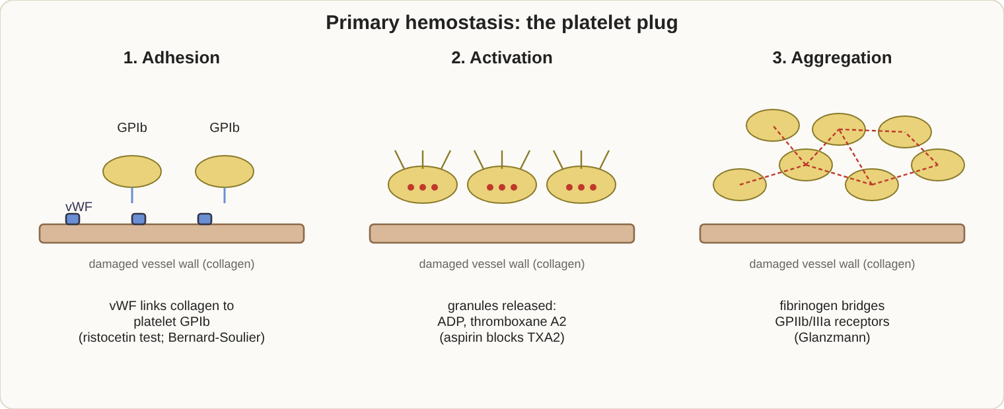
Primary hemostasis in three steps: adhesion, activation, aggregation.

Platelets (primary hemostasis)
Disorder | Cause | Key tests
Bernard-Soulier | Missing GPIb; giant platelets | Fails ristocetin, not corrected by normal plasma
Glanzmann thrombasthenia | Missing GPIIb/IIIa | Normal ristocetin; fails ADP and collagen
von Willebrand disease | Low or defective vWF | Long bleeding time, low ristocetin cofactor, aPTT may be long
ITP | Antibodies destroy platelets | Low count, large platelets, megakaryocytes present
Normal platelet count is about 150-450 x 10^9/L. A falsely low count from EDTA clumping or satellitism is rechecked with a citrate tube and a smear.
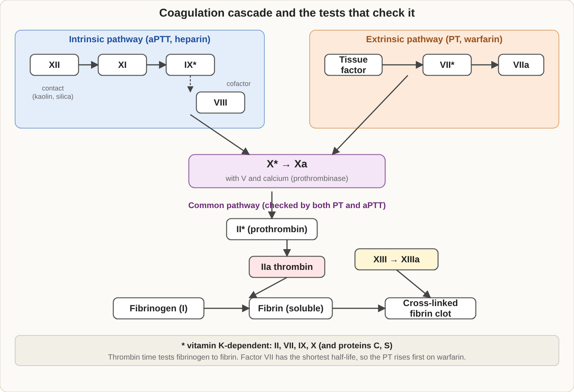
Coagulation cascade. aPTT tests the intrinsic and common pathways; PT tests the extrinsic and common pathways.

Coagulation (secondary hemostasis)
- Intrinsic (aPTT): XII, XI, IX, VIII. Extrinsic (PT): VII. Common: X, V, II, fibrinogen.
- Heparin is monitored with aPTT (or anti-Xa). Warfarin is monitored with PT/INR; it lowers II, VII, IX, X and proteins C and S.
Pattern | Think
PT long, aPTT normal | Factor VII deficiency, early warfarin, early liver disease
aPTT long, PT normal | Hemophilia A (VIII) or B (IX), factors XI and XII, heparin, vWD, lupus anticoagulant
Both long | Common pathway (X, V, II, fibrinogen), DIC, severe liver disease, high-dose warfarin or heparin
Both normal but bleeding | Factor XIII deficiency (clot solubility test), platelet function disorder, vWD
- Mixing study: a prolonged time that corrects with normal plasma = factor deficiency. No correction = an inhibitor (lupus anticoagulant, factor inhibitor).
- Lupus anticoagulant: long aPTT, no correction on mixing, corrected by extra phospholipid; confirm with dRVVT.
- Thrombin time: long with heparin and low or abnormal fibrinogen. Reptilase time stays normal with heparin.
- DIC: long PT and aPTT, low fibrinogen, low platelets, high D-dimer and FDPs, schistocytes.
- Primary fibrinolysis: high FDPs but normal D-dimer and normal platelets. D-dimer is specific for breakdown of cross-linked fibrin.
- Specimen: 3.2% sodium citrate, full draw; PT is stable up to 24 hours at room temperature; aPTT within 4 hours, and within 1 hour (centrifuged) for heparin patients. A hematocrit above 55% needs less citrate.

CBC problems and fixes
Problem | Effect | Fix
Cold agglutinins | High MCV and MCHC, low RBC | Warm the sample to 37 degrees C and rerun
Lipemia, high WBC or icterus | Falsely high Hgb | Plasma blank or saline replacement
Platelet clumping | Falsely low platelets (and sometimes high WBC) | Recollect in citrate, check the smear
Microclots | Low counts | Recollect

Normal values (approximate adult ranges)
Test | Male | Female
Hemoglobin (g/dL) | 13.5-17.5 | 12.0-16.0
Hematocrit (%) | 41-53 | 36-46
RBC (x 10^12/L) | 4.5-5.9 | 4.0-5.2
WBC (x 10^9/L) | 4.5-11.0 | 4.5-11.0
Platelets (x 10^9/L) | 150-450 | 150-450
Differential: neutrophils 50-70%, lymphocytes 20-40%, monocytes 2-9%, eosinophils 1-4%, basophils 0-1%. Ranges differ a little between labs; always use the lab's own reference interval.
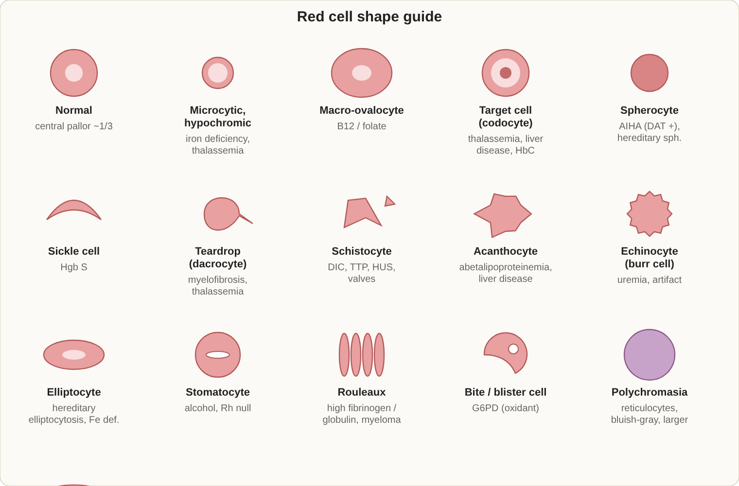
Red cell shapes and what they usually mean. These are teaching sketches, not photographs.

Red cell shape guide
Cell | Seen in
Spherocyte (no central pallor) | Autoimmune hemolysis, hereditary spherocytosis, burns
Target cell (codocyte) | Thalassemia, HbC, liver disease, iron deficiency, post-splenectomy
Sickle cell (drepanocyte) | Sickle cell disease
Teardrop (dacrocyte) | Myelofibrosis, thalassemia, marrow infiltration
Schistocyte, helmet cell | DIC, TTP, HUS, heart valves
Elliptocyte, ovalocyte | Hereditary elliptocytosis; macro-ovalocytes in megaloblastic anemia
Stomatocyte (slit-like pallor) | Hereditary stomatocytosis, alcoholism, Rh null
Acanthocyte (irregular spikes) | Liver disease, abetalipoproteinemia
Echinocyte, burr cell (regular spikes) | Uremia, artifact
Bite and blister cells | G6PD deficiency
Rouleaux | High protein: myeloma, inflammation
Agglutination | Cold agglutinins
Polychromasia | Reticulocytes: marrow responding
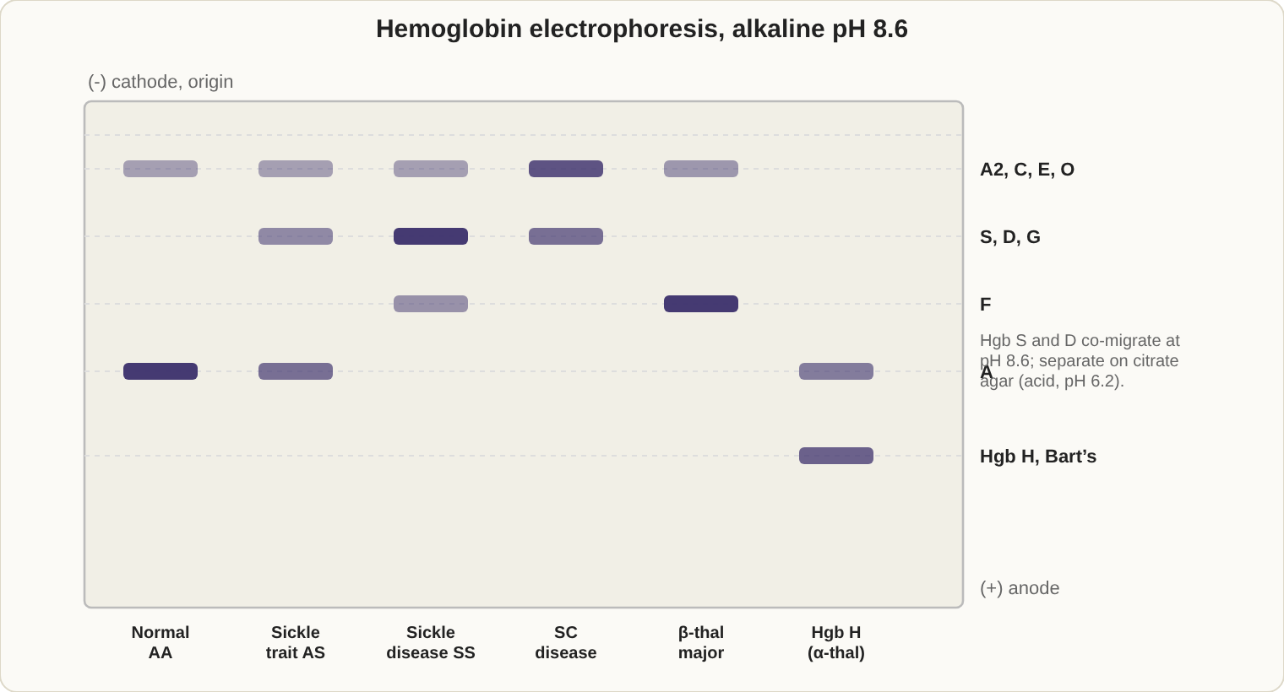
Alkaline (pH 8.6) hemoglobin electrophoresis. Cathode (-) at the top, anode (+) at the bottom.

Hemoglobin disorders
- Hemoglobin S: valine replaces glutamic acid at position 6 of the beta chain. Sickle trait (AS) has about 40% HbS and is usually harmless. HbC has lysine in the same position. HbSC disease is milder than SS.
- Sickle solubility test: deoxygenated HbS forms a cloudy suspension. It can be falsely negative in infants under 6 months or very low hemoglobin, and does not separate trait from disease, so confirm by electrophoresis.
- Beta thalassemia: trait has raised HbA2 (above 3.5%); major has little or no HbA with high HbF. Alpha thalassemia: 4 gene deletions = hydrops fetalis (Hb Barts); 3 = HbH disease; 1-2 = mild.
- Mentzer index = MCV / RBC count. Below 13 favors thalassemia; above 13 favors iron deficiency.
- HPFH (hereditary persistence of fetal hemoglobin): high HbF with normal red cell indices.
- Kleihauer-Betke acid elution: HbF resists acid, so fetal cells stay pink among ghost adult cells (counts fetal-maternal bleeding).

More on white cells and lymphoid disease
Finding | Common causes
Neutrophilia | Bacterial infection, steroids, stress
Eosinophilia | Allergy, parasites, drug reactions
Basophilia | CML and other myeloproliferative disease
Monocytosis | TB, recovery from infection, chronic inflammation
Lymphocytosis | Viral infection, pertussis; CLL in older adults
Neutropenia | Drugs, viral infection, marrow failure
- Myelodysplastic syndromes (MDS): dysplasia in one or more cell lines, usually macrocytosis, pseudo-Pelger-Huet cells, ring sideroblasts; blasts below 20% (WHO).
- Erythrocytosis: relative (low plasma volume, dehydration), absolute primary (polycythemia vera, JAK2, low EPO), absolute secondary (high EPO from hypoxia, smoking, tumors).
- Lymphomas: Hodgkin has Reed-Sternberg cells (owl-eye, CD15 and CD30). Burkitt shows a "starry sky" with t(8;14) and MYC. Follicular lymphoma has t(14;18) and BCL2. Mantle cell has t(11;14) and cyclin D1, CD5 positive.
- Myeloma: more than 10% plasma cells, monoclonal protein, "CRAB" (high calcium, renal failure, anemia, bone lesions). Waldenstrom: IgM paraprotein and thick blood (hyperviscosity).
- Platelet disorders: TTP has ADAMTS13 deficiency with schistocytes and low platelets; HUS follows E. coli O157 in children with kidney failure; HIT (heparin-induced thrombocytopenia) shows a platelet drop 5-10 days after heparin starts, caused by antibodies to heparin-PF4, and is treated with a direct thrombin inhibitor (argatroban).

Hemolysis indicators
Test | In hemolysis
Haptoglobin | Low (binds free hemoglobin)
LD | High
Indirect bilirubin | High
Reticulocytes | High
Free plasma hemoglobin | High (pink plasma)
Urine hemosiderin | Positive in chronic intravascular hemolysis

More hemostasis tests
Test | What it shows
PFA-100 closure time | Screens platelet function and vWD; long with aspirin, vWD, platelet defects
Platelet aggregation | Bernard-Soulier: absent ristocetin response. Glanzmann: absent response to ADP, collagen and epinephrine but normal ristocetin. vWD: ristocetin low. Aspirin: weak epinephrine, collagen and arachidonic acid response
Fibrinogen (Clauss) | Low in DIC, liver disease
Factor assays | Patient plasma mixed with factor-deficient plasma; results as percent activity
Bethesda assay | Measures factor inhibitors (Bethesda units)
Anti-Xa | Monitors LMWH and heparin
Thromboelastography (TEG) | Whole-blood clot strength and lysis
Heparin neutralization | Protamine, polybrene or reptilase removes heparin effect
Hypercoagulable states: factor V Leiden (APC resistance; the most common inherited cause), prothrombin G20210A, protein C, protein S and antithrombin deficiency, antiphospholipid antibodies (lupus anticoagulant, anticardiolipin), high homocysteine. Protein C and S are vitamin K dependent and fall on warfarin, so do not interpret them while on warfarin. Antithrombin deficiency causes heparin resistance.

Other hematology tests
- ESR (Westergren): rises with inflammation and rouleaux; falls with sickle cells and polycythemia. A tilted tube, vibration, or old specimen change the result.
- G6PD screen: fluorescent spot test; can be falsely normal right after a hemolytic crisis because old, deficient cells are gone.
- Osmotic fragility: increased in hereditary spherocytosis.
- Flow cytometry markers: T cells CD3, CD4, CD8; B cells CD19, CD20; myeloid CD13, CD33, CD117; monocytes CD14, CD64; stem cells CD34; megakaryocytes CD41, CD61; PNH loss of CD55 and CD59; CLL CD5, CD23.
- Molecular: BCR-ABL1 (CML), JAK2 V617F (polycythemia vera, ET, myelofibrosis), PML-RARA (APL).
- Automated counters: impedance (Coulter principle) counts and sizes cells by electrical pulses; histograms and flags alert to abnormal cells; RDW measures size variation; MPV measures platelet size.

Exam traps
- Target cells are seen in thalassemia and liver disease, not only in HbC.
- Heinz bodies do not show on Wright stain.
- A positive DAT separates autoimmune hemolysis from hereditary spherocytosis.
- A prolonged aPTT in a patient on heparin is expected; do not call it a factor deficiency without checking.

2. Clinical Chemistry (17-22%)
If you only remember 8 things
- Beer-Lambert law: absorbance is directly proportional to concentration.
- Glucose falls in unspun blood (glycolysis), so use a gray-top fluoride tube or separate the serum within 1 hour.
- Diabetes: fasting glucose 126 mg/dL or more, 2-hour OGTT 200 or more, HbA1c 6.5% or more.
- Troponin is the most specific marker for heart muscle damage.
- ALT = liver; AST = liver, heart and muscle; ALP and GGT = bile duct problems; lipase = pancreas.
- Anion gap = Na - (Cl + HCO3); normal about 8-16.
- High direct (conjugated) bilirubin = blockage; high indirect bilirubin = hemolysis or Gilbert.
- High TSH with low free T4 = primary hypothyroidism.
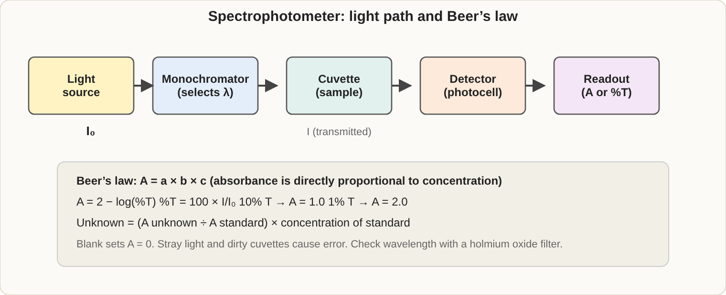
Light path of a spectrophotometer, and the Beer-Lambert relationships you may be asked to calculate.

Instruments and methods
Method | What it measures | Notes
Spectrophotometry | Absorbance of light | A = 2 - log %T; stray light and dirty cuvettes cause errors
Ion-selective electrode (ISE) | Na, K, Cl | Indirect ISE reads falsely low Na with lipemia or high protein (pseudohyponatremia)
Flame photometry | Na, K | Older method
Atomic absorption | Metals (lead, zinc, Ca, Mg)
Fluorometry | Very small amounts | More sensitive than absorbance
Nephelometry | Light scatter | Immunoglobulins and proteins
Osmometry | Freezing point drop | Osmolality
Gas chromatography / mass spectrometry | Drugs and toxins | Gold standard to confirm drug screens
Electrophoresis (pH 8.6) | Protein fractions | Albumin, alpha-1, alpha-2, beta, gamma, from anode to cathode
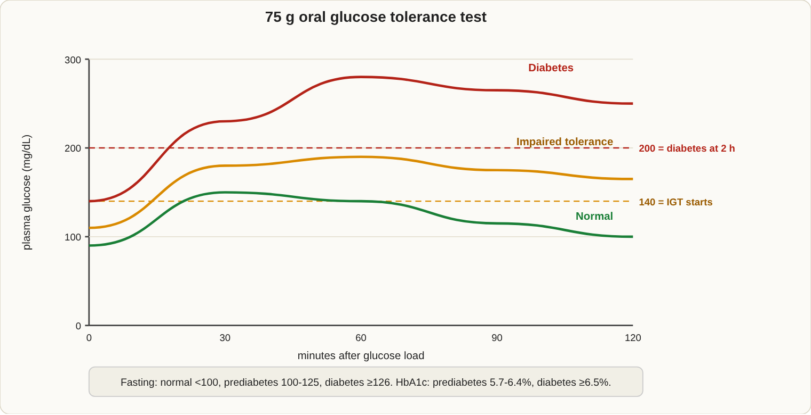
Oral glucose tolerance test patterns and diagnostic cut-offs (mg/dL).

Glucose and diabetes
- Hexokinase is the reference method; glucose oxidase is specific for glucose.
- HbA1c shows the last 2-3 months; fructosamine shows 2-3 weeks. A1c reads falsely low in hemolytic anemia and can be altered by hemoglobin variants.
- Low glucose with high insulin and high C-peptide = insulinoma. High insulin with low C-peptide = injected insulin.
- Urine ketones: nitroprusside detects acetoacetate and acetone, not beta-hydroxybutyrate.

Proteins and nitrogen compounds
- Total protein: biuret. Albumin: dye binding (bromcresol green or purple).
- Serum protein electrophoresis: monoclonal spike in the gamma region = myeloma (confirm with immunofixation); beta-gamma bridging = cirrhosis; flat alpha-1 band = alpha-1 antitrypsin deficiency.
- BUN/creatinine ratio above 20 suggests prerenal causes; normal is about 10-20.
- Creatinine by Jaffe (picric acid) is affected by glucose and ketones; enzymatic methods avoid this.
- Ammonia: collect on ice, test within 15-30 minutes; high in liver failure and Reye syndrome.
- Uric acid: gout; uricase method.
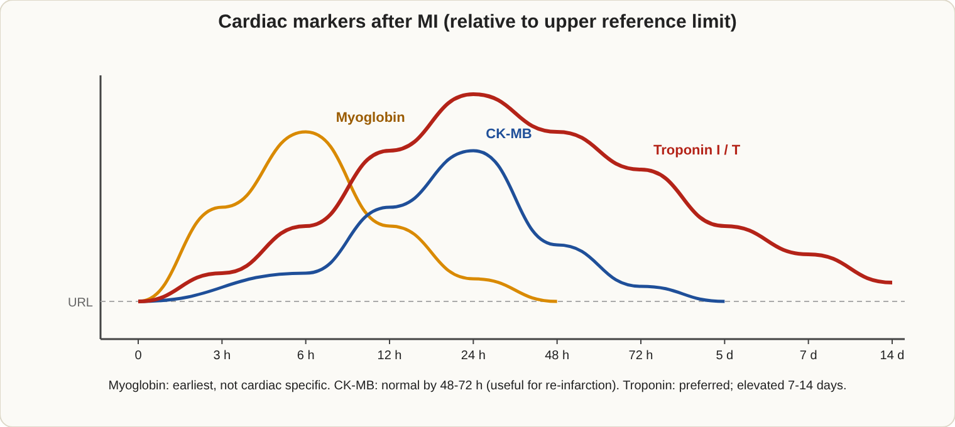
Cardiac marker timing after a myocardial infarction. Troponin stays up longest.

Cardiac markers
Marker | Rises | Peaks | Back to normal | Notes
Myoglobin | 1-3 h | 6-9 h | 24 h | Earliest but not specific
CK-MB | 3-6 h | 12-24 h | 2-3 days | Good for spotting re-infarction
Troponin I or T | 3-4 h | 12-24 h | 7-10 days or longer | Most specific; the preferred marker
BNP / NT-proBNP |  |  |  | Heart failure

Enzymes: what each one points to
Enzyme | Think
AST, ALT | Liver cell damage; ALT is more liver-specific, AST also in heart and muscle
ALP | Bile duct blockage and bone disease; GGT or 5'-nucleotidase shows it is liver
GGT | Biliary disease and alcohol
Amylase and lipase | Acute pancreatitis; lipase is more specific and lasts longer
CK | Muscle injury; MM skeletal, MB heart, BB brain
LD | Hemolysis, heart attack (LD1 higher than LD2 = flipped), cancers
Acid phosphatase | Prostate (PSA has largely replaced it)
Cholinesterase | Low in organophosphate poisoning
Enzyme rate assays that use NAD and NADH are read at 340 nm.

Electrolytes
- Normal ranges (mmol/L): Na 135-145, K 3.5-5.1, Cl 98-107, HCO3 22-29.
- Falsely high K: hemolysis, delayed separation, fist clenching, very high platelets.
- Anion gap = Na - (Cl + HCO3). Raised in MUDPILES: methanol, uremia, DKA, paraldehyde, iron or isoniazid, lactic acidosis, ethylene glycol, salicylates.
- Osmolal gap = measured - calculated, where calculated = 2 x Na + glucose/18 + BUN/2.8. A gap above about 10 points to toxic alcohols.
- Calcium: the ionized fraction is the active one; PTH raises calcium. Low magnesium causes arrhythmias and low K and Ca.
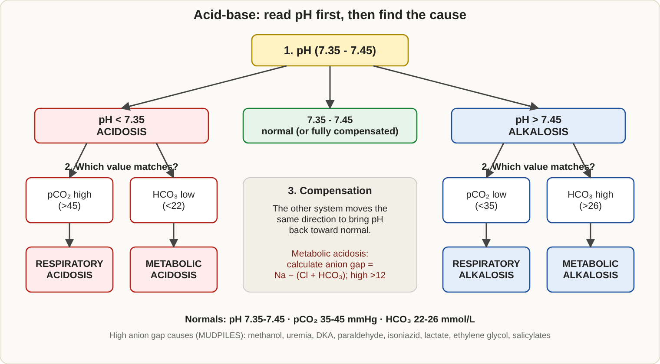
Step-by-step acid-base interpretation.

Acid-base
Normal blood gas: pH 7.35-7.45, pCO2 35-45 mmHg, HCO3 22-26 mmol/L. Henderson-Hasselbalch: pH = 6.1 + log (HCO3 / (0.03 x pCO2)).
Disorder | pH | Primary change | Body compensates by
Respiratory acidosis | Low | High pCO2 | Kidneys raise HCO3
Respiratory alkalosis | High | Low pCO2 | Kidneys lower HCO3
Metabolic acidosis | Low | Low HCO3 | Lungs lower pCO2
Metabolic alkalosis | High | High HCO3 | Lungs raise pCO2
Trick: compensation always moves the other number in the same direction as the primary change.
Blood gas specimens: heparin, no air bubbles, on ice if delayed. Air bubbles raise pO2 and lower pCO2.

Lipids
- Friedewald: LDL = total cholesterol - HDL - (triglycerides / 5). Not valid when triglycerides exceed 400 mg/dL; use a direct LDL.
- Fast 9-12 hours for triglycerides. A creamy top layer = chylomicrons; uniform cloudiness = VLDL.
- Desirable: total cholesterol below 200, LDL below 100, HDL above 40 (men) or 50 (women), triglycerides below 150.
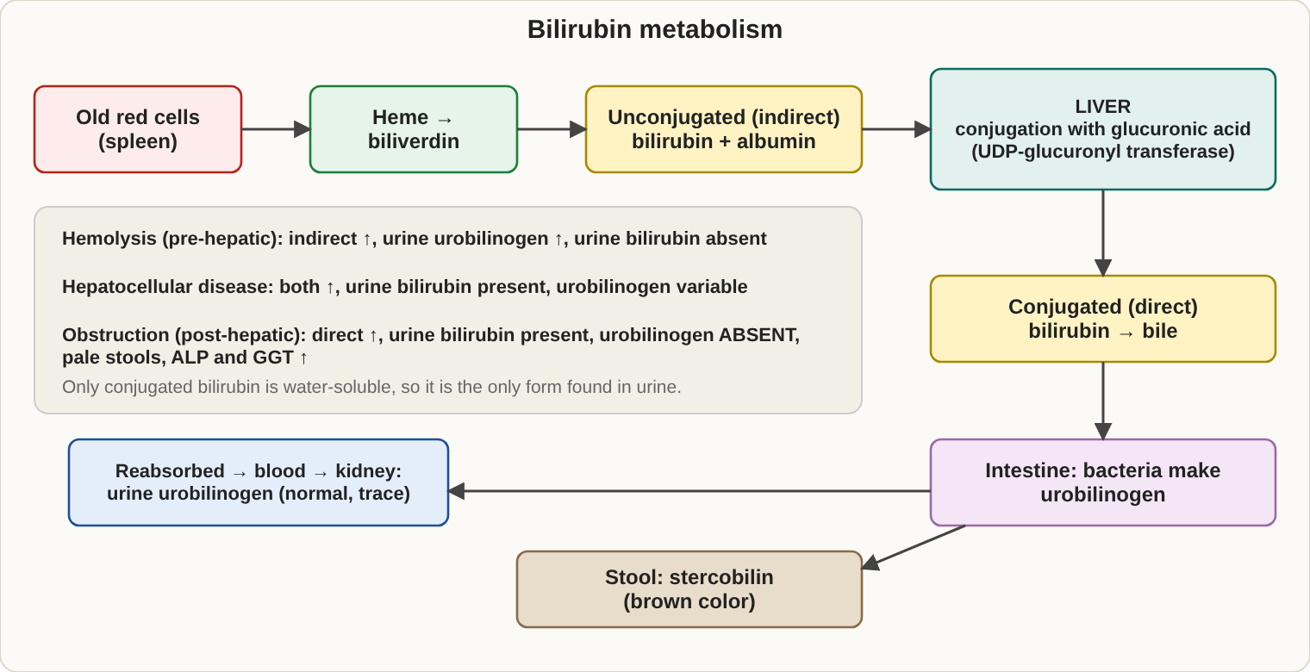
Bilirubin metabolism and where each type of jaundice fits.

Liver and bilirubin
Type | Bilirubin raised | Urine bilirubin | Urine urobilinogen | Other
Before the liver (hemolysis) | Indirect | Negative | High | Reticulocytes and LD high
In the liver (hepatitis) | Both | Positive | Variable | ALT and AST high
After the liver (blockage) | Direct | Positive | Low or absent | ALP and GGT high, pale stools
- Gilbert and Crigler-Najjar: indirect rise. Dubin-Johnson and Rotor: direct rise.
- Bilirubin breaks down in light; protect specimens.
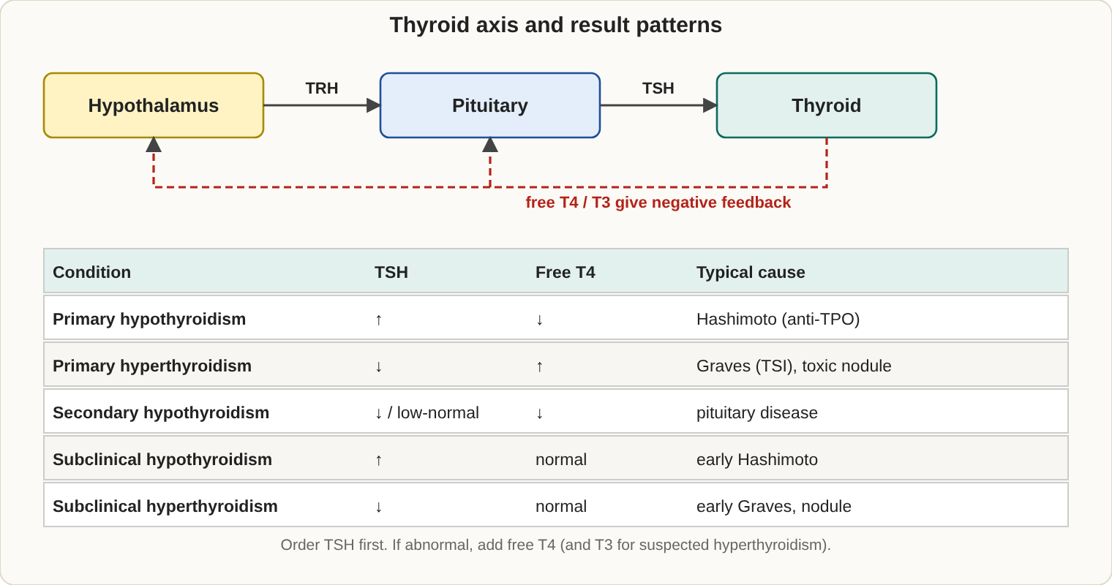
The thyroid feedback loop and the test patterns that follow from it.

Endocrine
Finding | Think
High TSH, low free T4 | Primary hypothyroidism (Hashimoto)
Low TSH, high free T4 | Hyperthyroidism (Graves)
Low TSH, low T4 | Pituitary (secondary)
High cortisol, fails dexamethasone suppression | Cushing
Low cortisol, poor ACTH stimulation response | Addison
High hCG | Pregnancy or trophoblastic disease
High AFP | Neural tube defect, liver tumor; low AFP in Down syndrome
High catecholamines, VMA | Pheochromocytoma, neuroblastoma
Tumor markers: PSA (prostate), CA-125 (ovary), CEA (colon), AFP (liver), CA 19-9 (pancreas).

Toxicology and drug monitoring
Drug | Key point
Acetaminophen | Use the Rumack-Matthew nomogram (from 4 hours); the antidote is N-acetylcysteine
Salicylate | Respiratory alkalosis first, then metabolic acidosis
Carbon monoxide | Carboxyhemoglobin by co-oximeter
Lead | Venous whole blood in a trace-metal-free tube, atomic absorption
Digoxin | Draw at least 6-8 hours after the dose; toxicity is worse with low K
Aminoglycosides | Peak after the dose, trough just before the next dose
Ethanol | Enzymatic (alcohol dehydrogenase) or gas chromatography
Drug levels reach steady state after about 5 half-lives.

Quick calculations
- Dilution factor = total volume / sample volume; multiply the result by the factor.
- Molarity = grams per liter / molecular weight. Percent solution (w/v) = grams per 100 mL.
- Glucose mg/dL / 18 = mmol/L. Cholesterol mg/dL x 0.0259 = mmol/L.

Glucose tolerance and diabetes categories
- Prediabetes: fasting glucose 100-125 mg/dL (impaired fasting glucose), 2-hour OGTT 140-199 (impaired tolerance), or HbA1c 5.7-6.4%.
- OGTT uses a 75 g glucose load after 3 days of normal carbohydrate intake and a fast of 8-12 hours.
- Gestational diabetes (ADA one-step 75 g test): positive if any one value is at or above fasting 92, 1 hour 180, or 2 hours 153 mg/dL. The two-step method starts with a 50 g non-fasting 1-hour screen.
- Urine albumin-to-creatinine ratio of 30-300 mg/g (microalbuminuria) is the earliest sign of diabetic kidney disease.

Lipoproteins
Particle | Carries | Main apolipoprotein
Chylomicron | Dietary triglyceride | B-48, C-II
VLDL | Liver-made triglyceride | B-100
LDL | Cholesterol to tissues | B-100
HDL | Cholesterol back to the liver (protective) | A-I
Lp(a) | LDL-like, raises clot and heart risk | Apo(a)
- Familial hypercholesterolemia: high LDL (defective LDL receptor). Lipoprotein lipase or apo C-II deficiency: very high chylomicrons and triglycerides, with a milky plasma that forms a creamy top layer.
- Lipoprotein electrophoresis order from the origin: chylomicrons, LDL (beta), VLDL (pre-beta), HDL (alpha).

Heme, porphyrins and myoglobin
- Heme synthesis starts with ALA synthase (the rate-limiting step), then ALA, porphobilinogen (PBG), porphyrins, and finally iron is added by ferrochelatase.
- Lead blocks ALA dehydratase and ferrochelatase: ALA and free erythrocyte protoporphyrin rise.
Porphyria | Defect and clues
Acute intermittent porphyria | PBG deaminase; abdominal pain and nerve symptoms, no skin disease; urine ALA and PBG high, urine darkens in light
Porphyria cutanea tarda | Uroporphyrinogen decarboxylase; blistering skin in sun; urine uroporphyrins
Congenital erythropoietic porphyria | Severe skin damage, red teeth
- PBG screening uses the Watson-Schwartz or Hoesch test (Ehrlich reagent).
- Myoglobin is a muscle heme protein; it appears in urine after muscle injury (rhabdomyolysis), turning urine red-brown and risking kidney damage.

Vitamins and trace elements
Vitamin | Deficiency
A (fat-soluble) | Night blindness
D (fat-soluble; measure 25-OH vitamin D) | Rickets, osteomalacia
E (fat-soluble) | Hemolysis, nerve damage
K (fat-soluble) | Bleeding; long PT
B1 (thiamine) | Beriberi, Wernicke encephalopathy
B3 (niacin) | Pellagra
B6 | Neuropathy, anemia
Folate | Megaloblastic anemia, neural tube defects
B12 | Pernicious anemia, nerve damage
C | Scurvy
- Copper: Wilson disease has low ceruloplasmin and liver and brain damage. Zinc: poor wound healing. Iodine: goiter. Selenium and chromium: nutrition and glucose metabolism.
- Calcium and phosphorus move in opposite directions: hyperparathyroidism gives high calcium and low phosphorus; hypoparathyroidism gives low calcium and high phosphorus; cancer-related high calcium has low PTH.
- Enzyme to remember: ACE (angiotensin-converting enzyme) is raised in sarcoidosis.

Hormones in more detail
- Steroid hormones (cortisol, aldosterone, estrogen, testosterone) come from cholesterol and act inside cells. Peptide hormones (insulin, GH, ACTH, PTH) act on surface receptors. Catecholamines come from tyrosine; test urine metanephrines and VMA.
- Rule for dynamic tests: suspected excess is tested with a suppression test; suspected deficiency is tested with a stimulation test.
Condition | Key findings
Conn syndrome | High aldosterone, low renin, low K
Acromegaly | High GH that fails to suppress with glucose; high IGF-1
Prolactinoma | High prolactin
Congenital adrenal hyperplasia | High 17-hydroxyprogesterone
Carcinoid tumor | High urine 5-HIAA
Pheochromocytoma | High metanephrines, catecholamines
Hyperparathyroidism | High PTH, high calcium

Therapeutic drug monitoring (TDM)
Drug class | Examples | Key points
Aminoglycosides | Gentamicin, tobramycin, amikacin | Kidney and ear toxicity; peak and trough
Glycopeptide | Vancomycin | Trough level
Cardioactive | Digoxin, procainamide, quinidine | Digoxin toxic with low K; procainamide has an active metabolite (NAPA)
Anticonvulsants | Phenytoin, valproic acid, carbamazepine, phenobarbital | Phenytoin is highly protein-bound; free level matters with low albumin
Antidepressants and mood | Tricyclics, lithium | Lithium: draw 12 hours after the dose; do not use a lithium-heparin tube
Immunosuppressants | Cyclosporine, tacrolimus, mycophenolate | Whole-blood EDTA trough
Others | Theophylline, methotrexate | Narrow therapeutic ranges

Toxicology
Toxin | Key points
Methanol | Formic acid; blindness; high anion gap and osmolal gap
Ethylene glycol | Oxalate crystals in urine; kidney failure; high osmolal gap
Ethanol | Enzymatic or GC; raises osmolality
Lead | Anemia, basophilic stippling, nerve damage
Mercury, arsenic, cadmium | Heavy metals; test by atomic absorption or ICP-MS
Carbon monoxide | Cherry-red look; carboxyhemoglobin
Organophosphates | Low cholinesterase
Cyanide | Blocks cytochrome oxidase; almond odor
Drugs of abuse | Immunoassay screen (can cross-react), then GC/MS or LC-MS confirmation

Standard curves and calibration
- A standard curve plots absorbance against known concentrations; a straight line shows Beer's law is obeyed. Read the patient's concentration from the line.
- A reagent blank sets zero. Results above the highest standard are diluted and rerun, then multiplied by the dilution factor.

Exam traps
- Pseudohyponatremia happens with indirect ISE, not direct ISE.
- The dipstick ketone test misses beta-hydroxybutyrate.
- Troponin is more specific than CK-MB; CK-MB normalizes sooner.
- ALP alone is not proof of liver disease; bone also raises it.

3. Microbiology (17-22%)
If you only remember 8 things
- Gram stain order: crystal violet, iodine, decolorizer, safranin. Over-decolorizing makes Gram-positives look negative.
- Catalase positive = Staphylococcus; catalase negative = Streptococcus. Coagulase positive = S. aureus.
- Strep ID: bacitracin-sensitive = group A; CAMP positive = group B; optochin-sensitive = S. pneumoniae; bile esculin positive = Enterococcus or group D.
- Oxidase negative = Enterobacterales. Oxidase positive = Pseudomonas, Neisseria, Vibrio, Campylobacter.
- On MacConkey agar, pink = lactose fermenter (E. coli, Klebsiella, Enterobacter). Colorless = non-fermenter (Salmonella, Shigella, Proteus).
- Haemophilus needs X and V factors and grows on chocolate agar.
- Malaria: the thick smear finds the parasite; the thin smear identifies the species.
- Never refrigerate CSF; Neisseria and Haemophilus die in the cold.
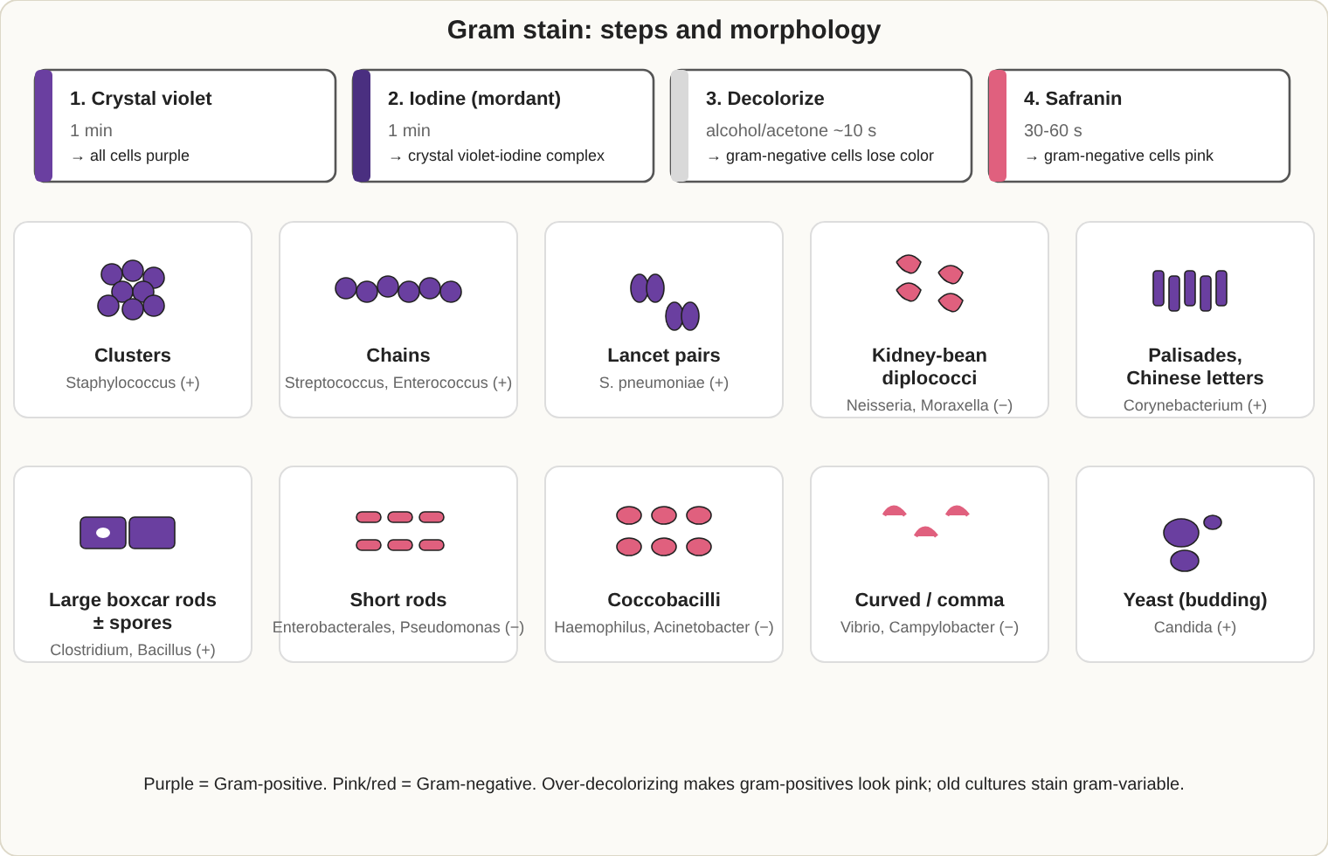
Gram stain steps and the shapes you must recognize on a smear.

Stains
Stain | Use
Gram | Routine; purple = positive, pink = negative
Acid-fast (Ziehl-Neelsen hot, Kinyoun cold) | Mycobacteria, Nocardia (weakly), Cryptosporidium, Cyclospora
Auramine-rhodamine | Fluorescent acid-fast screen
India ink | Cryptococcus capsule in CSF
KOH, calcofluor white | Fungal elements
Lactophenol cotton blue | Fungal structures

Culture media
Medium | What it is for
Blood agar | General growth; shows hemolysis (alpha = green partial, beta = clear complete, gamma = none)
Chocolate agar | Haemophilus and Neisseria (need X and V factors)
MacConkey | Gram-negative rods; lactose fermenters pink
EMB | Gram-negative rods; E. coli has a green metallic sheen
Hektoen, XLD, SS | Salmonella and Shigella; H2S gives black colonies
CIN | Yersinia enterocolitica (bull's-eye colony)
Thayer-Martin, Martin-Lewis | Neisseria gonorrhoeae
Campy-BAP at 42 degrees C, microaerophilic | Campylobacter jejuni
TCBS | Vibrio (V. cholerae yellow, V. parahaemolyticus green)
Mannitol salt | S. aureus (yellow, mannitol positive)
Bile esculin | Enterococcus and group D strep (black)
Regan-Lowe, Bordet-Gengou | Bordetella pertussis
Loeffler, Tinsdale | Corynebacterium diphtheriae
Lowenstein-Jensen, Middlebrook | Mycobacteria
Sabouraud dextrose | Fungi
BCYE | Legionella (needs cysteine and iron)
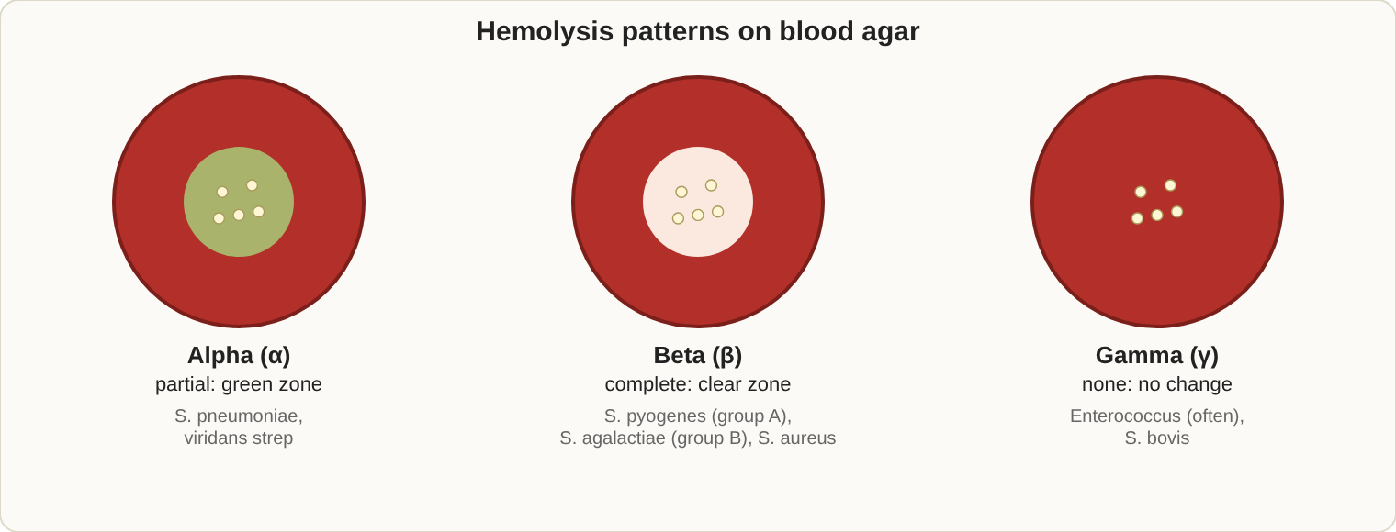
Hemolysis on 5% sheep blood agar.
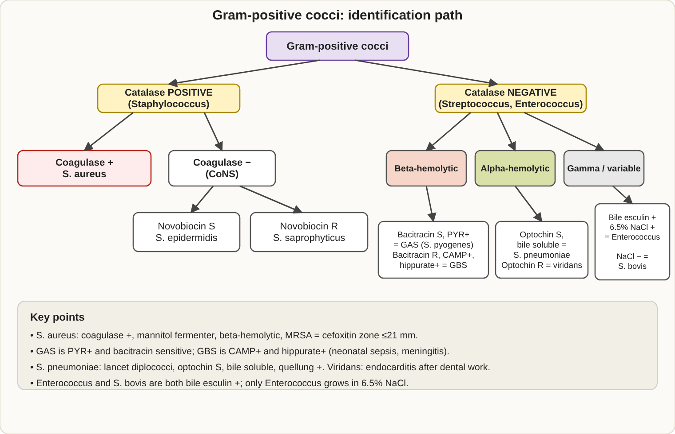
Identification path for Gram-positive cocci. Memorize the decision at each step.

Gram-positive cocci
Organism | Key tests and facts
S. aureus | Catalase +, coagulase +, mannitol +; MRSA carries mecA
S. epidermidis | Coagulase negative, novobiocin sensitive; skin contaminant, device infections
S. saprophyticus | Coagulase negative, novobiocin resistant; urinary infections in young women
S. pyogenes (group A) | Beta-hemolytic, bacitracin sensitive, PYR +; strep throat, rheumatic fever
S. agalactiae (group B) | Beta-hemolytic, CAMP +, hippurate +; newborn sepsis and meningitis
S. pneumoniae | Alpha-hemolytic, optochin sensitive, bile soluble, lancet-shaped diplococci
Viridans streptococci | Alpha-hemolytic, optochin resistant; endocarditis
Enterococcus | Bile esculin +, grows in 6.5% NaCl, PYR +; vancomycin resistance = VRE
S. bovis group | Bile esculin +, no growth in 6.5% NaCl; colon cancer link

Gram-negative cocci
- N. gonorrhoeae: ferments glucose only, oxidase +, intracellular diplococci.
- N. meningitidis: ferments glucose and maltose, capsule, meningitis.
- Moraxella catarrhalis: DNase +, butyrate esterase +.
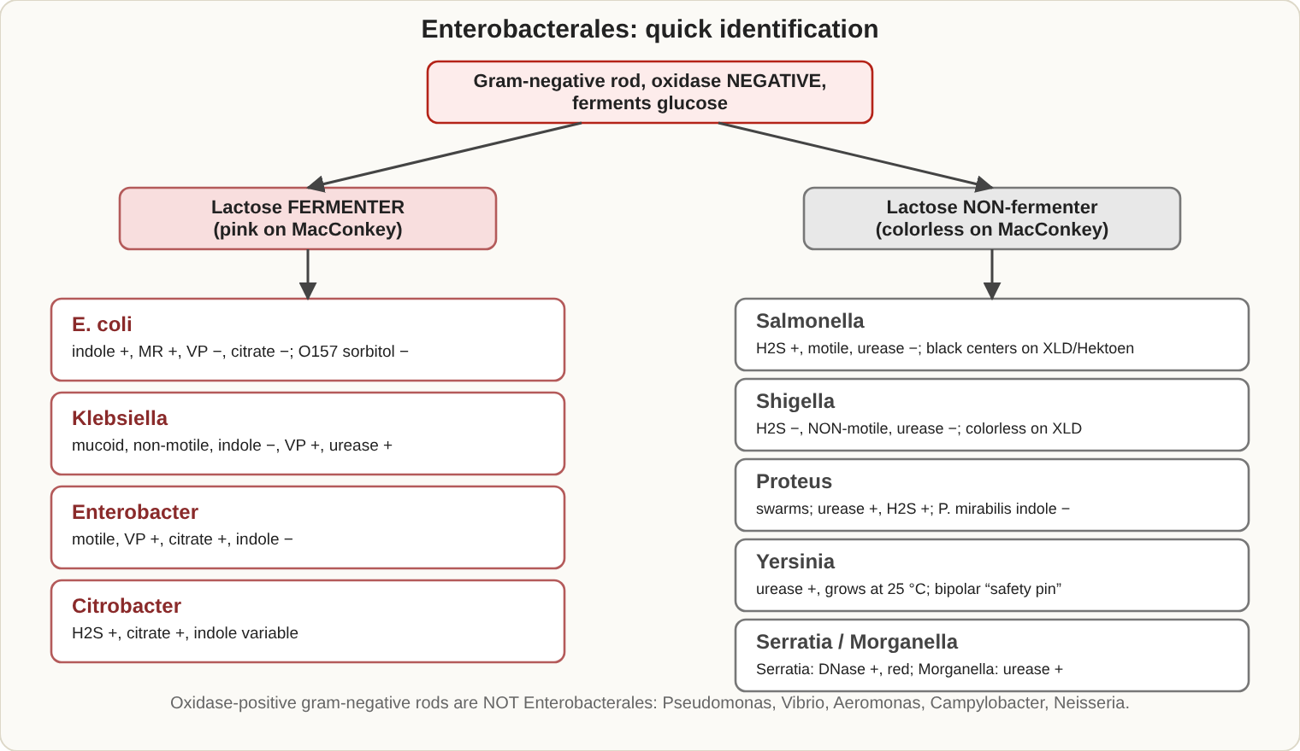
Enterobacterales: separate by lactose, then use the quick tests.

Enterobacterales (oxidase negative, glucose fermenters)
Organism | Quick clues
E. coli | Lactose +, indole +, citrate negative; most common urinary pathogen. O157:H7 is sorbitol negative on SMAC (hemolytic uremic syndrome)
Klebsiella | Mucoid, lactose +, nonmotile, indole negative (K. pneumoniae)
Enterobacter | Lactose +, motile, citrate +, VP +
Salmonella | Lactose negative, H2S +, motile
Shigella | Lactose negative, nonmotile, no H2S, no gas
Proteus | Swarming, urease +, H2S +, PAD +
Serratia | Red pigment, DNase +, gelatinase +
Citrobacter | H2S +, citrate +, lactose variable
Yersinia | Y. pestis bipolar "safety pin" (plague); Y. enterocolitica grows in the cold, urease +
TSI tube: A/A = ferments glucose plus lactose or sucrose; K/A = glucose only; K/K = non-fermenter. Black = H2S; cracks or bubbles = gas.
IMViC (E. coli pattern ++--): indole +, methyl red +, VP negative, citrate negative. Klebsiella and Enterobacter are the opposite (--++).

Non-fermenters and other Gram-negative rods
Organism | Key facts
Pseudomonas aeruginosa | Oxidase +, blue-green pigment (pyocyanin), grape-like odor, grows at 42 degrees C; burns and cystic fibrosis
Stenotrophomonas maltophilia | Oxidase negative, maltose +, resistant to carbapenems
Acinetobacter | Oxidase negative, nonmotile, multidrug resistant
Haemophilus influenzae | Needs X and V; satellites around S. aureus
Legionella | BCYE agar, faint on Gram stain, urine antigen test
Bordetella pertussis | Regan-Lowe; nasopharyngeal swab (Dacron or calcium alginate)
Campylobacter jejuni | Curved "gull-wing", oxidase +, grows at 42 degrees C
Helicobacter pylori | Urease +; urea breath test
Vibrio cholerae | Oxidase +, yellow on TCBS, rice-water stools
Brucella, Francisella | Small coccobacilli; high lab-acquired infection risk, work in a biosafety cabinet

Anaerobes and other Gram-positive rods
- Bacteroides fragilis: bile resistant; resistant to kanamycin, vancomycin and colistin. Gram-negative anaerobes are naturally resistant to aminoglycosides.
- Clostridium perfringens: double zone of hemolysis, lecithinase +, stormy fermentation, gas gangrene.
- C. difficile: toxin A and B (PCR for the toxin gene); antibiotic-associated colitis.
- C. botulinum (neurotoxin) and C. tetani (drumstick spores).
- Listeria: tumbling motility at 25 degrees C, beta-hemolytic, grows at 4 degrees C.
- Corynebacterium diphtheriae: club-shaped, Elek test for toxin.
- Bacillus anthracis: nonmotile, nonhemolytic, "medusa head" colonies. B. cereus: motile, beta-hemolytic, food poisoning.
- Nocardia: branching and weakly acid-fast. Actinomyces: sulfur granules.

Mycobacteria
- M. tuberculosis: slow grower, niacin +, nitrate +, cording. Runyon groups: I photochromogens, II scotochromogens, III nonphotochromogens, IV rapid growers.
- M. kansasii: photochromogen. M. marinum: photochromogen, water exposure, grows at 30 degrees C. M. avium complex: nonphotochromogen, HIV patients. M. leprae: cannot be grown in culture.
- Specimens are digested and decontaminated (NALC-NaOH) before culture.

Fungi
Group | Examples and clues
Dermatophytes | Trichophyton (skin, hair, nails), Microsporum (skin, hair), Epidermophyton (skin, nails)
Dimorphic fungi (mold at 25 degrees C, yeast at 37) | Histoplasma (tuberculate macroconidia), Blastomyces (broad-based budding), Coccidioides (arthroconidia, highly infectious), Sporothrix
Yeasts | Candida albicans: germ tube +. Cryptococcus: India ink capsule, urease +, antigen test
Molds | Aspergillus: septate hyphae with acute-angle branching. Mucor and Rhizopus: broad ribbon-like hyphae without septa, seen in diabetics

Parasites
- Specimens: stool for ova and parasites, trichrome stain for protozoa, concentration by formalin-ethyl acetate. Pinworm (Enterobius) by Scotch tape test.
- Protozoa: Entamoeba histolytica (trophozoite with ingested RBCs), Giardia (pear-shaped, "falling leaf"), Cryptosporidium and Cyclospora (acid-fast oocysts), Trichomonas (jerky motility).
Malaria species | Clues
P. falciparum | Multiple rings in one cell, banana-shaped gametocytes; most dangerous
P. vivax | Enlarged red cells, Schuffner dots, ameboid forms
P. ovale | Oval, fringed red cells
P. malariae | Band forms, rosette schizonts, 72-hour cycle
P. knowlesi | Band forms, 24-hour cycle
- Others in blood: Babesia (Maltese cross), Trypanosoma, Leishmania (amastigotes in macrophages), microfilariae.
- Worm eggs: Ascaris (mammillated coat), Trichuris (barrel with polar plugs), hookworm (thin shell), Enterobius (flat on one side), Diphyllobothrium (operculated; B12 deficiency), Schistosoma (lateral spine = mansoni, terminal spine = haematobium, small lateral knob = japonicum).

Other organisms
- Herpes simplex shows multinucleated giant cells; CMV shows "owl-eye" inclusions; respiratory viruses are now mostly detected by molecular tests.
- Chlamydia trachomatis is an obligate intracellular organism found by NAAT. Mycoplasma has no cell wall (cold agglutinins). Treponema is seen by darkfield microscopy.
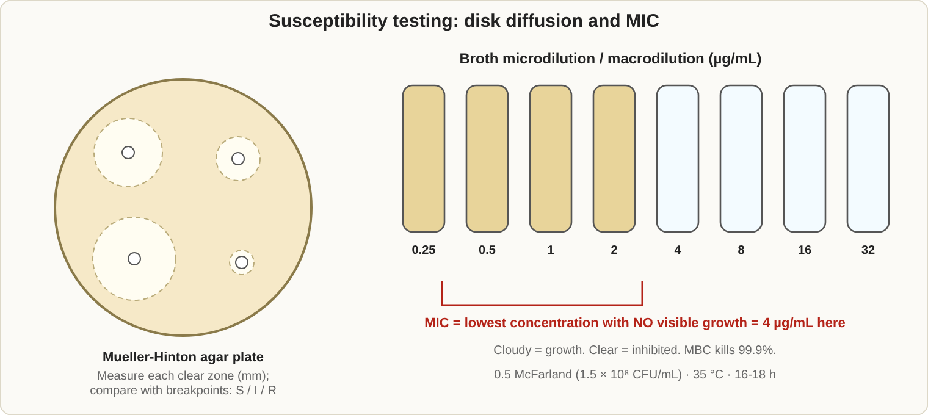
Disk diffusion (Kirby-Bauer) and broth dilution MIC.

Susceptibility testing
- Kirby-Bauer disk diffusion: Mueller-Hinton agar, 0.5 McFarland standard, 4 mm depth, 35 degrees C for 16-18 hours; measure the zone and read it against CLSI breakpoints.
- MIC: the lowest concentration that stops visible growth (broth dilution).
- QC strains: E. coli ATCC 25922, S. aureus ATCC 25923 (disk) or 29213 (MIC), P. aeruginosa ATCC 27853, E. faecalis ATCC 29212.
Resistance | Mechanism or test
MRSA | mecA gene (PBP2a); oxacillin or cefoxitin resistant
VRE | vanA or vanB genes
ESBL | Resists third-generation cephalosporins; clavulanate synergy confirms
Carbapenemase (KPC, NDM, OXA-48) | Modified carbapenem inactivation or molecular tests
Inducible clindamycin resistance | D-test (erythromycin flattens the clindamycin zone)
Beta-lactamase | Nitrocefin (cefinase) test

Specimen rules
- Blood cultures: two sets, skin cleaned with chlorhexidine; a single positive bottle with skin organisms is usually a contaminant.
- CSF: process immediately, never refrigerate.
- Urine: clean catch; 100,000 CFU/mL is the traditional infection threshold.
- Sputum quality: more than 25 white cells and fewer than 10 squamous epithelial cells per low-power field.
- Possible bioterror agents (anthrax, plague, tularemia, brucellosis): do rule-out only in the sentinel lab and notify public health.

Common pathogens by body site
Site | Usual pathogens
Blood | S. aureus, E. coli, Klebsiella, streptococci, enterococci, Candida; coagulase-negative staph is usually a contaminant
Urine | E. coli (most common), S. saprophyticus, Klebsiella, Proteus, Enterococcus, Pseudomonas, Candida
Upper respiratory | S. pyogenes, C. diphtheriae, Bordetella pertussis, N. meningitidis carriage
Lower respiratory | S. pneumoniae, H. influenzae, Moraxella, Klebsiella, Legionella, Mycoplasma, M. tuberculosis, Pneumocystis, Pseudomonas in cystic fibrosis
Stool | Salmonella, Shigella, Campylobacter, E. coli pathotypes, Yersinia, Vibrio, C. difficile
Genital tract | N. gonorrhoeae, C. trachomatis, T. pallidum, Gardnerella, Trichomonas, Candida, HSV, H. ducreyi
Skin and soft tissue | S. aureus, S. pyogenes, Pseudomonas (hot tubs), Pasteurella (animal bites), Vibrio vulnificus (seawater)
Bone | S. aureus; Salmonella in sickle cell disease
Meningitis by age
Age | Usual bacteria
Newborn | Group B strep, E. coli, Listeria
Child | S. pneumoniae, N. meningitidis, H. influenzae
Adult | S. pneumoniae, N. meningitidis
Older adult | S. pneumoniae, Listeria, Gram-negative rods

E. coli types that cause diarrhea
Type | Key points
ETEC | Traveler's diarrhea; heat-labile and heat-stable toxins
EPEC | Infant diarrhea
EIEC | Invades like Shigella; slow lactose fermenter
EHEC (STEC, O157:H7) | Shiga toxin; bloody diarrhea without fever; hemolytic uremic syndrome; sorbitol negative
EAEC | Persistent diarrhea

Vaginitis
Cause | Findings
Bacterial vaginosis (Gardnerella) | pH above 4.5, positive "whiff" (fishy) test, clue cells, few white cells
Candida | Normal pH, budding yeast and pseudohyphae on KOH
Trichomonas | pH above 4.5, motile flagellates on wet mount, white cells

Basic identification tests
Test | Principle and meaning
Catalase | Bubbles with hydrogen peroxide: Staph (positive), Strep (negative)
Oxidase | Cytochrome oxidase; purple color: Pseudomonas, Neisseria, Vibrio, Campylobacter
Coagulase | Clots plasma: S. aureus
PYR | Group A strep and Enterococcus positive
Urease | Proteus, H. pylori, Cryptococcus, Brucella
Indole | Tryptophanase; red ring: E. coli, Proteus vulgaris
Bile solubility | S. pneumoniae dissolves in bile
DNase | S. aureus, Serratia, Moraxella
Hippurate | Group B strep, Campylobacter jejuni
Nitrate reduction | Most Enterobacterales positive

Modern identification methods
- MALDI-TOF mass spectrometry: matches a protein profile of a colony; fast and accurate for most bacteria and yeasts.
- Multiplex PCR panels: detect many pathogens and resistance genes directly from blood culture bottles, stool, spinal fluid, or respiratory samples.
- 16S rRNA sequencing: identifies organisms that cannot be named by routine methods.
- Automated systems (Vitek, Phoenix, MicroScan) identify and test susceptibility. Continuous-monitoring blood culture systems (BACTEC, BacT/Alert) detect growth by CO2 production.

Select agents and BSL-3 organisms
Sentinel labs do only a rule-out, work in a biosafety cabinet, avoid sniffing plates, notify public health, and refer to the Laboratory Response Network (LRN).
Agent | Clues
Bacillus anthracis | Large Gram-positive rod, nonhemolytic, "medusa head" colonies, nonmotile
Yersinia pestis | Bipolar "safety pin" rod, grows slowly, plague
Francisella tularensis | Tiny Gram-negative coccobacillus, needs cysteine (chocolate agar), very infectious
Brucella | Tiny coccobacillus, slow growth, urease positive, unpasteurized dairy
Burkholderia pseudomallei and mallei | Oxidase positive, can be misidentified by automated systems
Clostridium botulinum | Neurotoxin

Giemsa, acridine orange and other stains
- Giemsa: blood parasites, Chlamydia inclusions, intracellular Histoplasma.
- Acridine orange: fluorescent stain that finds bacteria and fungi when the Gram stain is hard to read.
- Modified acid-fast (weak acid, 1% H2SO4): Nocardia, Cryptosporidium, Cyclospora, Isospora.
- Trichrome: intestinal protozoa in stool.

Viruses to know
Virus | Key points
Herpes simplex | Multinucleated giant cells; PCR is the best test
Varicella-zoster | Chickenpox and shingles
CMV | "Owl-eye" inclusions; dangerous in transplant recipients and newborns
EBV | Mononucleosis; Burkitt lymphoma
Adenovirus | Conjunctivitis, respiratory and gut infections
RSV | Bronchiolitis in infants; syncytia in culture
Influenza | Seasonal; rapid antigen tests and PCR
Rabies | Negri bodies in brain tissue
Parvovirus B19 | Fifth disease; aplastic crisis in hemolytic anemia
Norovirus and rotavirus | Common viral gastroenteritis

Natural resistance to remember
Organism | Intrinsically resistant to
Klebsiella | Ampicillin
Pseudomonas aeruginosa | Many drugs: ampicillin, first-generation cephalosporins, trimethoprim-sulfamethoxazole
Enterococcus | Cephalosporins, low-level aminoglycosides
Stenotrophomonas | Carbapenems
Anaerobes | Aminoglycosides
Gram-negative rods | Vancomycin

Collection, rejection and reporting
- Reject specimens that are unlabeled, leaking, in the wrong container, too old, or contaminated (for example 24-hour sputum, Foley tip, swab from a surface ulcer).
- Use anaerobic transport for anaerobe cultures; do not refrigerate gonorrhea or CSF specimens; stool needs prompt testing or the right preservative; boric acid preserves urine for delayed transport.
- Call as a critical value: positive blood culture, positive CSF Gram stain or culture, suspected select agent.
- Reportable to public health (varies by state): TB, Salmonella, Shigella, measles, syphilis, gonorrhea, Chlamydia, hepatitis, anthrax, plague, tularemia, brucellosis.
- Corrected reports are marked clearly, the original is kept, and the clinician is told.
- Screening cultures: MRSA (nasal swab; mecA PCR or chromogenic agar), VRE (rectal swab, bile esculin vancomycin plate), ESBL and CRE (rectal swab, selective agar or PCR) are collected for infection control.

Exam traps
- Strep pneumoniae is alpha-hemolytic but is told apart from viridans strep by optochin and bile solubility.
- Salmonella and Shigella are both lactose negative; Shigella is nonmotile with no H2S.
- Acid-fast stains also pick up Nocardia (weakly) and Cryptosporidium.
- A thick malaria smear finds parasites; only the thin smear gives the species.

4. Blood Banking (17-22%)
If you only remember 8 things
- Type O red cells are the universal donor; group AB plasma is the universal donor plasma. Forward and reverse ABO typing must agree.
- Anti-A and anti-B are IgM and react at room temperature. Rh, Kell, Kidd and Duffy antibodies are IgG and react at 37 degrees C or AHG.
- After A and B, the D antigen is the most immunogenic.
- DAT = coating on red cells inside the patient. IAT = looking for antibody in serum. A negative AHG test needs check cells to be valid.
- Kidd antibodies cause delayed hemolytic reactions and fade quickly. Duffy antibodies are destroyed by enzymes.
- Suspect a transfusion reaction: stop the transfusion, keep the IV open, check the paperwork, send a post-transfusion sample.
- RhIG (300 micrograms) within 72 hours for an Rh-negative mother with an Rh-positive baby; the Kleihauer-Betke test counts fetal cells.
- Shelf lives: red cells 42 days (AS-1), platelets 5 days at room temperature with agitation, plasma 1 year frozen.
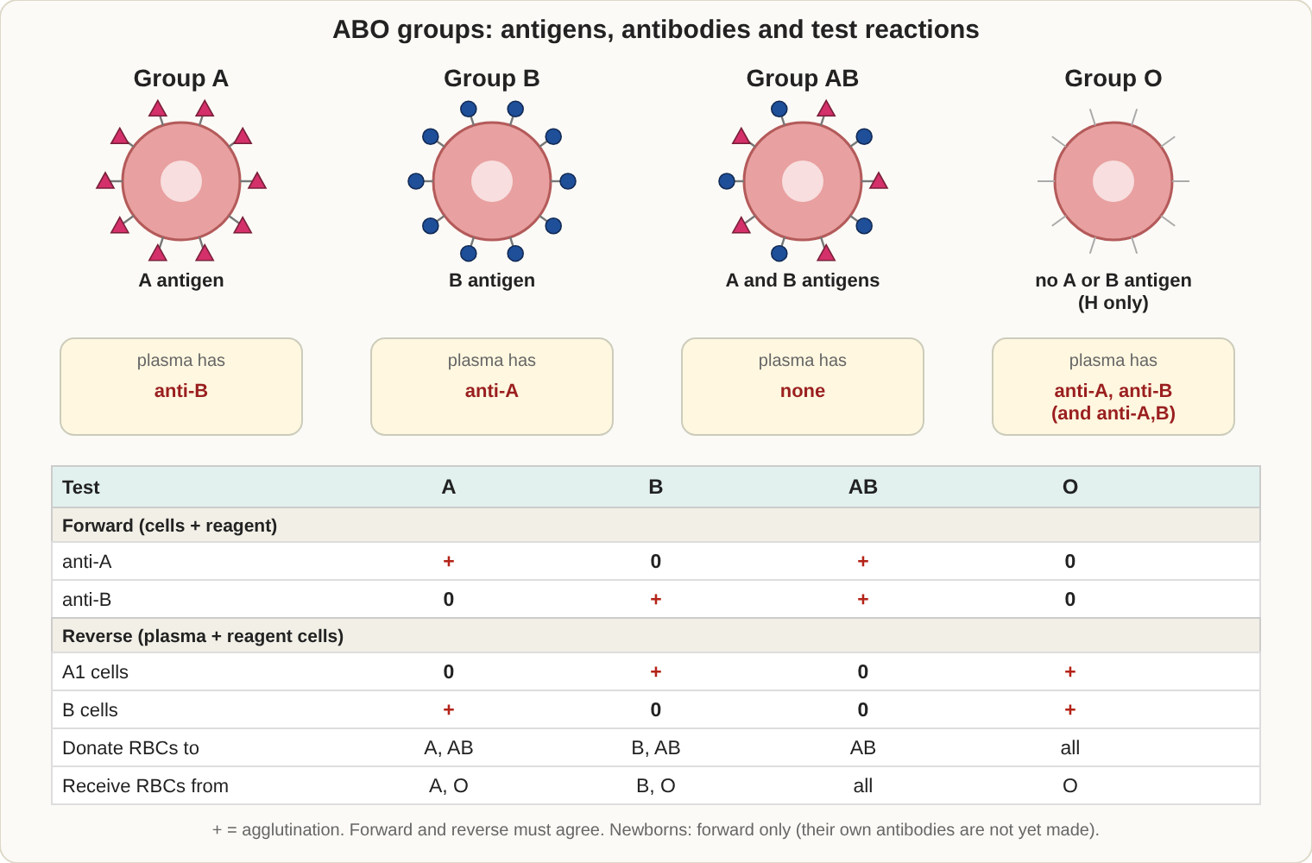
ABO antigens on red cells, antibodies in plasma, and what each typing reaction looks like.

ABO system
Blood type | Antigens on red cells | Antibodies in serum
A | A | Anti-B
B | B | Anti-A
AB | A and B | None
O | None (only H) | Anti-A, anti-B, anti-A,B
- Forward type = patient red cells with anti-A and anti-B. Reverse type = patient serum with A1 and B cells.
- Bombay phenotype (hh): no H, so no A or B. It types as O, but the serum contains anti-H and reacts with all group O cells. Only Bombay blood is compatible.
- Newborns and elderly people may have weak or missing ABO antibodies.
Common ABO discrepancies
Cause | Clue | Fix
Weak antibodies | Missing reverse reaction (newborn, elderly) | Incubate longer or at 4 degrees C
Subgroup of A (A2 with anti-A1) | Extra reverse reaction with A1 cells | Test with anti-A1 lectin
Cold autoantibody | Extra reaction at room temperature | Prewarm or use saline at 37 degrees C
Rouleaux | Stacked cells in forward and reverse | Saline replacement
Acquired B antigen | Weak B on A patients (colon cancer, infection) | Acidified anti-B
Mixed-field | Two cell populations (recent transfusion, transplant) | Review history

Rh system
- Rh-negative means no D antigen. Rh antibodies are IgG, do not bind complement, and cause extravascular hemolysis and HDFN.
- Weak D is tested with AHG for donors, who are labeled Rh positive if weak D is found. Patients with weak D are usually treated as Rh positive.
- Common haplotypes (Fisher-Race): R0 = Dce, R1 = DCe, R2 = DcE, Rz = DCE, r = dce, r' = dCe, r'' = dcE, ry = dCE.
- Rh null cells lack all Rh antigens (stomatocytes, chronic hemolysis).
- Enzymes (ficin, papain): enhance Rh, Kidd, Lewis, I and P1; destroy Duffy, M, N, S (variable) and Xga.

Other blood groups
System | Antibody | Key points
Kell | IgG | Second most immunogenic after D; antigens destroyed by DTT and AET
Duffy | IgG | Destroyed by enzymes; Fy(a-b-) resists P. vivax malaria
Kidd | IgG, binds complement | Delayed hemolytic reactions; titer falls quickly, so it can be missed
MNS | M and N usually IgM, S and s IgG | Show dosage
Lewis | IgM | Adsorbed from plasma; does not cause HDFN; changes in pregnancy
P1 | IgM | Hydatid cyst fluid neutralizes anti-P1
I / i | IgM cold autoantibodies | Anti-I in cold agglutinin disease and Mycoplasma; anti-i in mononucleosis
- Dosage: antibodies react more strongly with cells from homozygous people (e.g. Jk(a+b-) versus Jk(a+b+)). It occurs in Rh, Kidd, Duffy and MNS.
- Finding compatible donors: multiply the frequency of antigen-negative blood for each antibody. If 91% of donors are K negative and 34% are Fya negative, then 0.91 x 0.34 = about 31% of units will be compatible.
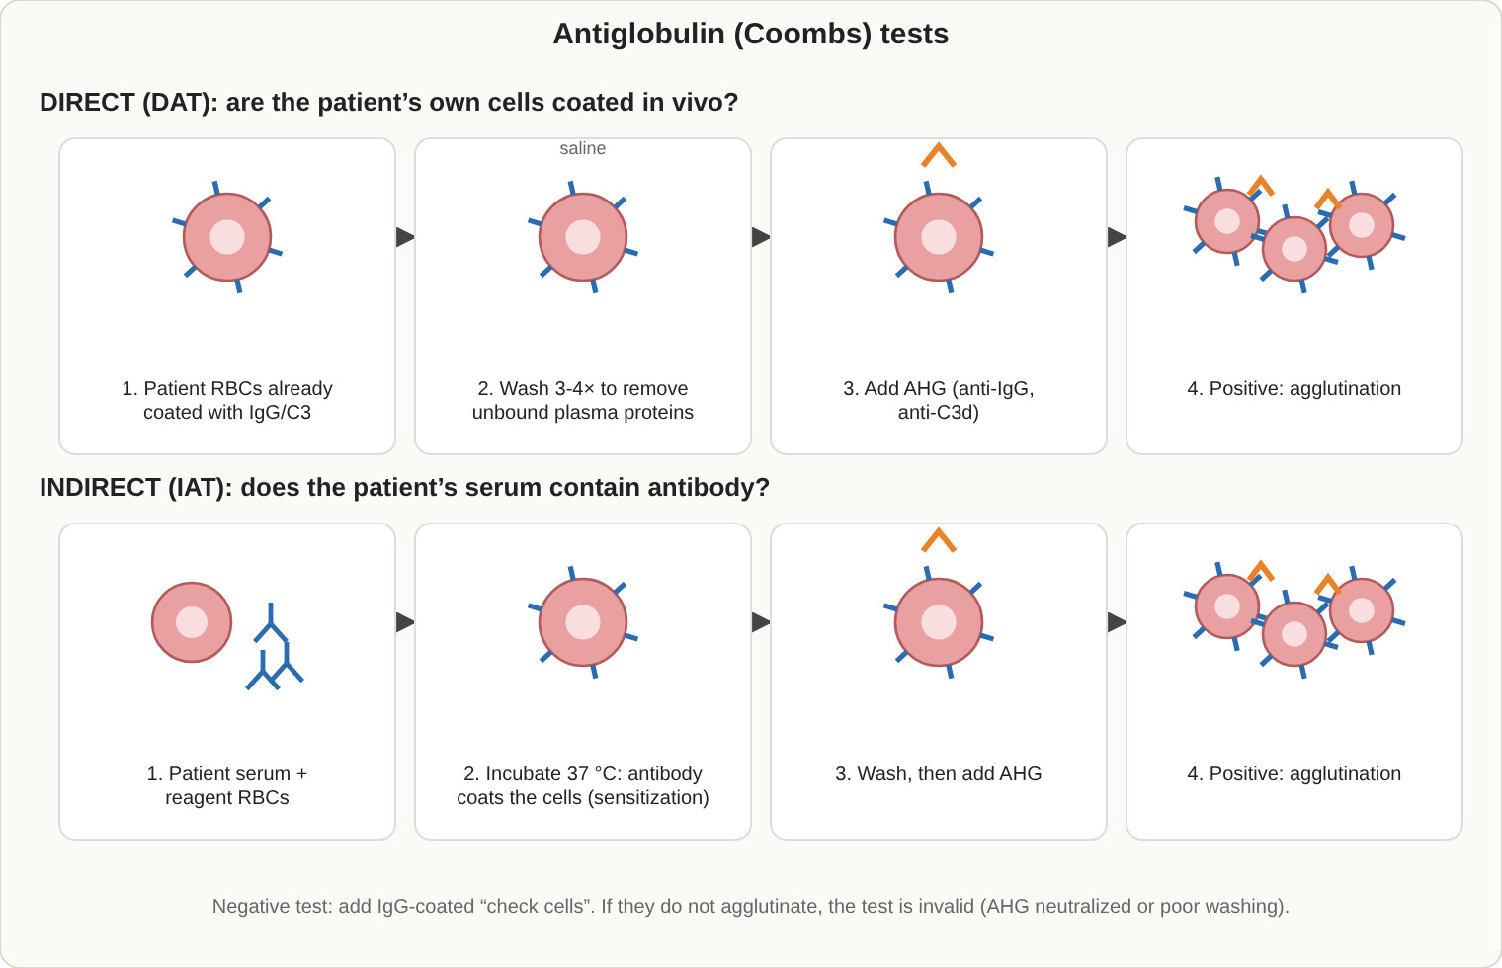
Direct and indirect antiglobulin tests. Both end with AHG bridging IgG-coated red cells.

Antiglobulin (Coombs) testing
- DAT detects in-vivo sensitization: HDFN, hemolytic transfusion reaction, autoimmune hemolytic anemia, drug-induced hemolysis.
- IAT detects in-vitro sensitization: antibody screen, antibody identification, AHG crossmatch.
- Polyspecific AHG contains anti-IgG and anti-C3d. Check cells (IgG-coated) are added to every negative AHG test; if they do not agglutinate, the test is invalid.
- False negatives: poor washing (free serum neutralizes AHG), delayed reading, forgetting AHG. False positives: overcentrifugation, contaminated reagents.
- Enhancement media: LISS, PEG, albumin.

Antibody screen and identification
- The screen uses 2 or 3 group O cells with known antigens. Compare the autocontrol with the panel to tell alloantibody from autoantibody.
- Panel rules: rule out an antibody using cells that lack the antigen (best with homozygous cells); rule in with reactive cells. The rule of three needs 3 positive and 3 negative cells for 95% confidence.
- Warm autoantibody (IgG): panel and autocontrol all positive. Cold autoantibody (IgM): reacts at room temperature; prewarm.
- Useful treatments: DTT destroys IgM and Kell; chloroquine removes IgG from cells; elution removes antibody from red cells (used in HDFN, delayed reactions and AIHA).

Crossmatch and pretransfusion testing
- Pretransfusion testing: ABO and Rh, antibody screen, crossmatch. A sample must be recent (within 3 days) if the patient was transfused or pregnant in the last 3 months.
- Immediate-spin crossmatch (ABO check only) is allowed when the screen is negative and there is no antibody history. Use a full AHG crossmatch if the screen is positive or there is a history of antibodies. Electronic crossmatch needs a validated system and two ABO types on record.
- Emergency release: group O red cells (Rh negative for women of childbearing age), with a physician's signed statement.
- RhIG: 300 micrograms covers 30 mL of fetal whole blood (15 mL of fetal red cells). Screen with a rosette test; count with Kleihauer-Betke or flow cytometry.
RhIG dose calculation: KB fetal cell % x 50 = mL of fetal whole blood. Divide by 30 to get vials. If the decimal is 0.5 or more, round up; if less than 0.5, round down; then add one extra vial.

Blood components
Component | Storage | Shelf life | Notes
Red cells (AS-1) | 1-6 degrees C | 42 days | One unit raises Hgb about 1 g/dL, Hct about 3%
Whole blood (CPDA-1) | 1-6 degrees C | 35 days
Frozen red cells | At or below -65 degrees C | 10 years | After thawing, 24 hours
Platelets | 20-24 degrees C, agitated | 5 days (7 with bacterial testing) | Random unit raises count 5,000-10,000; apheresis 30,000-60,000
Fresh frozen plasma | At or below -18 degrees C | 1 year | Thawed: 24 hours at 1-6 degrees C; all clotting factors
Cryoprecipitate | At or below -18 degrees C | 1 year | Thawed single unit within 6 hours; pooled within 4 hours; fibrinogen, VIII, vWF, XIII
Granulocytes | 20-24 degrees C | 24 hours | Irradiate; give quickly
Washed red cells | 1-6 degrees C | 24 hours | IgA-deficient patients, severe allergic reactions
- Leukoreduced (fewer than 5 x 10^6 white cells): prevents febrile reactions, CMV transmission and HLA alloimmunization.
- Irradiated (at least 25 Gy): prevents transfusion-associated graft-versus-host disease. Used for fetuses, immunocompromised patients, relative-directed donations and HLA-matched products.
- Stored red cells lose 2,3-DPG (oxygen curve shifts left) and gain potassium.
- Cryoprecipitate treats low fibrinogen, factor XIII deficiency and DIC.

Donor requirements
Item | Rule
Hemoglobin | At least 12.5 g/dL (or hematocrit 38%)
Weight | At least 110 lb
Temperature | 99.5 F or lower
Pulse | 50-100
Blood pressure | No higher than 180/100
Whole blood interval | 56 days
Platelet apheresis | Every 7 days, up to 24 a year
Double red cell | Every 16 weeks
Autologous donor | Hgb at least 11 g/dL
- Required tests: ABO and Rh, antibody screen, HIV-1/2 (antibody and NAT), HCV (antibody and NAT), HBsAg and anti-HBc, HTLV-I/II, West Nile NAT, syphilis, Chagas (first donation).
- Deferrals: malaria (3 months after travel, 3 years after living in an endemic area), pregnancy (6 weeks after delivery), HIV risk, hepatitis.
- Collection: 450 mL (plus or minus 10%) in 63 mL anticoagulant; clean the arm with chlorhexidine or iodine; divert the first 30-40 mL.
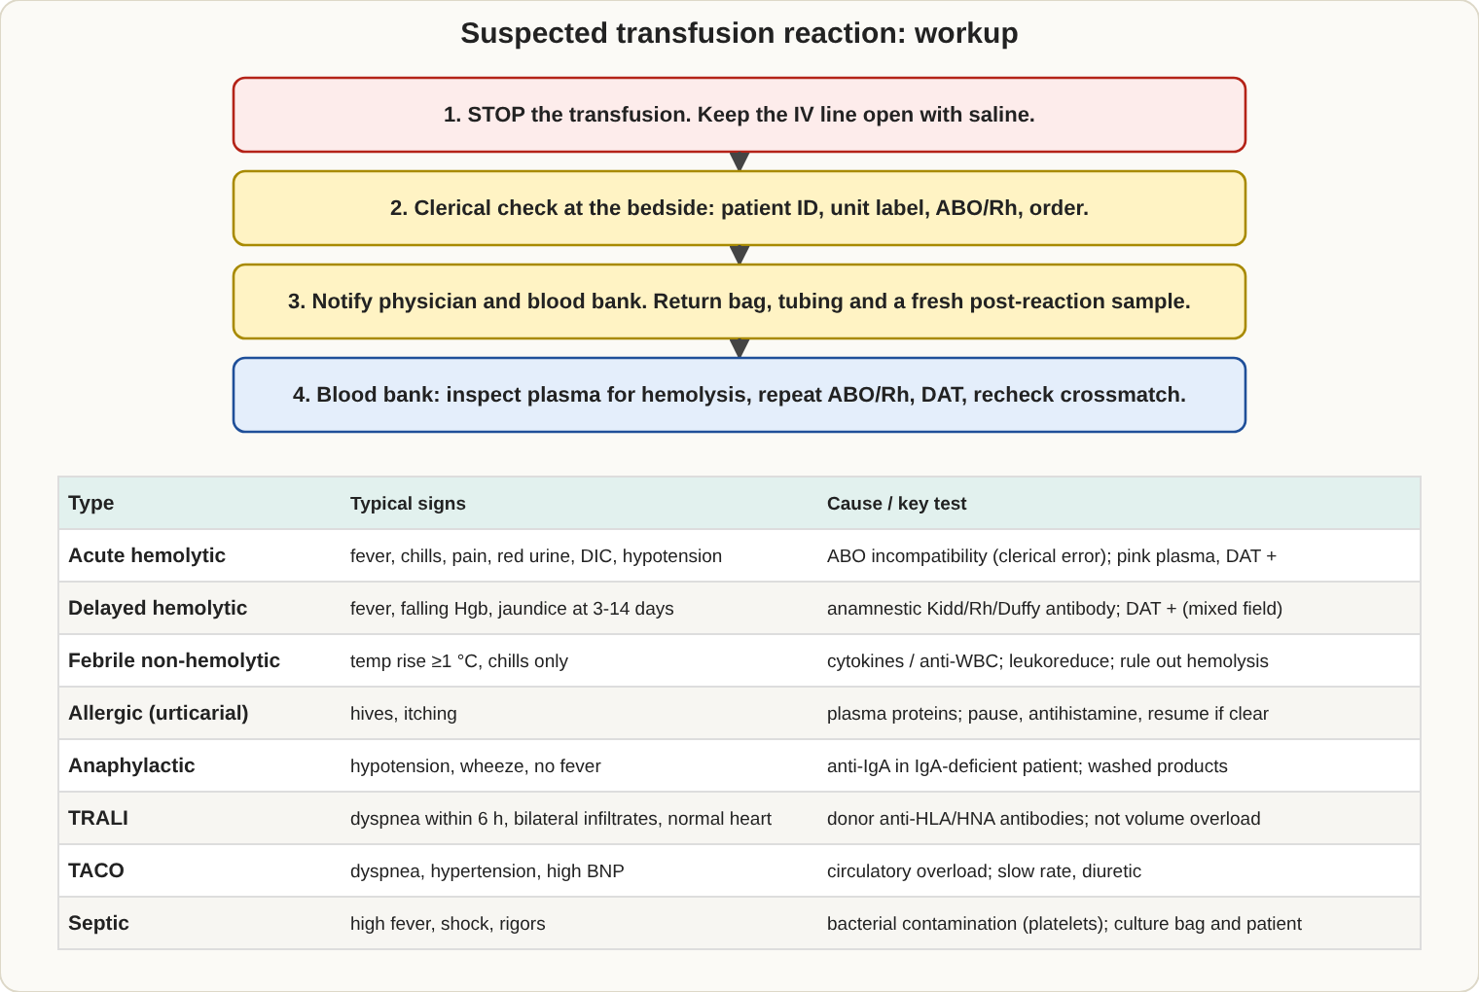
What to do if a transfusion reaction is suspected, and how to sort the cause.

Transfusion reactions
Reaction | When | Cause and clues
Acute hemolytic | During or within 24 hours | ABO incompatibility, usually a clerical error. Fever, back pain, red plasma, red urine, positive DAT, DIC
Delayed hemolytic | 3-14 days | Memory antibody (Kidd, Rh, Duffy, Kell). New antibody on screen, positive DAT, mild jaundice
Febrile nonhemolytic | During or up to 4 hours after | Cytokines from white cells. Temperature rise of 1 degree C or more; diagnosis of exclusion
Allergic (hives) | During or within 4 hours | Antihistamine; transfusion may continue
Anaphylactic | Within minutes | IgA-deficient patient with anti-IgA; use washed or IgA-deficient products
TRALI | Within 6 hours | Donor antibodies to recipient white cells; lung edema, normal heart pressures
TACO | Within 6 hours | Circulatory overload; high BNP, high blood pressure; slow rate and diuretics
Graft-versus-host | 4-30 days | Donor lymphocytes attack; fever, rash, diarrhea, pancytopenia; irradiation prevents it
Septic | During or within hours | Bacteria in the unit (platelets most often); Gram stain and culture the bag
Post-transfusion purpura | 5-10 days | Anti-HPA-1a; sudden low platelets
Workup order for a suspected hemolytic reaction: stop the transfusion, keep the IV open with saline, check the labels and paperwork, notify the physician and blood bank, collect a post-transfusion sample, look at the plasma for pink color, repeat ABO and Rh, and run a DAT.

Hemolytic disease of the fetus and newborn (HDFN)
 | ABO HDFN | Rh HDFN
Mother and baby | Mother O, baby A or B | Mother Rh negative with anti-D, baby Rh positive
Severity | Usually mild | Can be severe
DAT on baby | Weak or negative | Positive
Smear | Spherocytes | Many nucleated red cells
Prevention | None | RhIG
- Exchange transfusion blood should be fresh (less than 7 days), group O, antigen-negative, CMV-safe and irradiated, and compatible with the mother's serum.
- Cord blood tests: ABO and Rh, DAT. If the mother is Rh negative, test the baby for weak D.

Technique tips
- Grading: 4+ (one solid clump) down to 1+, W+ (weak), 0 (negative). Hemolysis counts as positive.
- Undercentrifugation lowers sensitivity; overcentrifugation can cause false positives.
- Drug-induced hemolysis: penicillin (drug coats the cell), methyldopa (autoantibody), quinidine (immune complex).
- Wharton's jelly contamination of cord blood causes false clumping; wash the cells at least 6 times.
- HLA: class I (A, B, C) on all nucleated cells and platelets; class II (DR, DQ, DP) on B cells and antigen-presenting cells. Platelet refractoriness is often HLA antibodies, so use HLA-matched platelets.

When to transfuse (typical adult guidance)
Product | Common indication
Red cells | Hemoglobin below about 7 g/dL (below 8 for heart disease or orthopedic surgery), or symptoms of poor oxygen delivery
Platelets | Prophylaxis if count is below 10,000 per microliter; below 50,000 with active bleeding or before surgery
Fresh frozen plasma | Multiple factor deficiencies, warfarin reversal with bleeding, TTP (as exchange)
Cryoprecipitate | Fibrinogen below 100-150 mg/dL, factor XIII deficiency
Granulocytes | Severe neutropenia with infection not responding to antibiotics
Massive bleeding | Balanced transfusion of red cells, plasma and platelets (about 1:1:1)
Giving blood safely: use only 0.9% saline in the same line (no drugs, no dextrose, no Ringer's lactate), a standard filter (170-260 micron), start slowly for the first 15 minutes while watching the patient, record vital signs, and finish the unit within 4 hours. Use a blood warmer for massive transfusion or cold agglutinin patients.

Component quality control (approximate AABB standards)
Component | What is checked
Red cells | Hematocrit not above 80%; leukoreduced units below 5 x 10^6 white cells
Platelets (random unit) | At least 5.5 x 10^10 platelets; pH at least 6.2 at the end of storage
Platelets (apheresis) | At least 3.0 x 10^11 platelets
Cryoprecipitate | At least 80 IU factor VIII and 150 mg fibrinogen per unit
Irradiation | 25 Gy to the center, 15 Gy minimum anywhere
Storage | Refrigerator 1-6 degrees C with alarm and continuous record; platelet agitators checked

Plasma derivatives and apheresis
- Fractionation products: albumin, IVIG, Rh immune globulin, hepatitis B and tetanus immune globulin, factor VIII and IX concentrates. They are pooled and virus-inactivated.
- Therapeutic apheresis: plasma exchange (TTP, Guillain-Barre, myasthenia gravis, hyperviscosity), red cell exchange (sickle cell disease), leukapheresis (very high white count), photopheresis.
- Extracorporeal circulation (heart-lung bypass, dialysis) uses heparin; cell salvage and autologous donation reduce the need for donor blood. This is part of patient blood management.
- Donor reactions: vasovagal fainting is the most common (lie down, cool cloth, fluids); apheresis donors may get citrate reactions (tingling lips, treat with calcium or slow the return).

Special serologic techniques
Technique | Purpose
Titration | Measures antibody strength (anti-D in pregnancy; a titer of 16 or more is significant)
Adsorption | Removes autoantibody (with the patient's own or other cells) to find hidden alloantibodies
Elution | Frees antibody from red cells for identification (acid, heat, ether)
Neutralization | Soluble antigen blocks antibody: Lewis substance in saliva, hydatid cyst fluid for anti-P1
Lectins | Dolichos biflorus is anti-A1; Ulex europaeus is anti-H
Thiol reagents (DTT, 2-ME) | Destroy IgM and Kell antigens
Chloroquine | Removes IgG from red cells so antigens can be typed on DAT-positive cells
EDTA-glycine acid | Strips IgG from red cells (also destroys Kell antigens)
Solid phase and column (gel) agglutination | Automated, standardized, graded reactions
Molecular (genotyping) | Finds red cell antigens in recently transfused or DAT-positive patients
Cytotoxicity and platelet testing | HLA typing, platelet crossmatching

Immune hemolytic anemias
Type | Antibody | Key points
Warm autoimmune | IgG, panreactive | Spherocytes, DAT positive for IgG (with or without C3); lupus, CLL
Cold agglutinin disease | IgM anti-I | Red cells clump in the cold; DAT positive for C3 only; Mycoplasma, mononucleosis (anti-i)
Paroxysmal cold hemoglobinuria | IgG anti-P, biphasic | Donath-Landsteiner test; children after viral infection
Drug-induced | Varies | Penicillin (drug on cell), methyldopa (autoantibody), quinidine (immune complex)

High- and low-prevalence antigens
- An antibody to a high-prevalence antigen (anti-k, anti-Kpb, anti-Jsb, anti-Vel) reacts with almost all panel cells but not the autocontrol; compatible blood is rare and may need the rare donor registry.
- An antibody to a low-prevalence antigen (anti-Kpa, anti-Wra) gives a single odd reaction, but nearly all donor units are compatible.

Genetics of ABO
- A and B are codominant over O. Parents AO and BO can have any of the four types. Parents AB and O can only have A or B children. O parents can only have O children.
- Rh-negative (dd) parents can only have Rh-negative children; D-positive parents may be DD or Dd.

Transplantation and blood
- Solid organs need ABO compatibility; kidney, heart and liver also use HLA crossmatching to detect preformed antibodies.
- Stem cell (HPC) transplant: major mismatch (recipient has antibodies to donor cells) can cause delayed hemolysis or pure red cell aplasia; minor mismatch (donor plasma antibodies against recipient cells) can cause hemolysis from passenger lymphocytes. Products are irradiated; the transfusion service selects group O red cells and AB plasma or platelets during the switch.

Rh immune globulin timing
- Give RhIG to Rh-negative women at about 28 weeks of pregnancy and within 72 hours of delivery of an Rh-positive baby. Also give after miscarriage, abortion, ectopic pregnancy, amniocentesis, abdominal trauma.
- RhIG is not given if the mother already has anti-D from sensitization, or if she is Rh positive (including weak D).

Quality assurance in the blood bank
- Test reagent red cells, antisera and AHG with positive and negative controls on each day of use. Refrigerators and freezers are checked and recorded daily with alarms.
- Keep the patient's sample and the donor segments for at least 7 days after transfusion. Records of donors, patients and transfusions are kept for the required period (often 5 years or longer).

Exam traps
- Lewis and P1 antibodies are IgM and do not cause HDFN; Rh antibodies do.
- Ficin and papain destroy Duffy but enhance Rh and Kidd.
- A negative AHG test without a positive check-cell result is invalid.
- Group O is universal for red cells; group AB is universal for plasma.

5. Immunology and Serology (5-10%)
If you only remember 8 things
- IgM appears first and is the best complement fixer; IgG is the most abundant and crosses the placenta; IgA protects mucosal surfaces; IgE causes allergy.
- T cells carry CD3; helper T cells CD4 (the HIV target); cytotoxic T cells CD8; B cells CD19 and CD20; NK cells CD16 and CD56.
- Complement: C1q starts the classical pathway; C5b-9 is the membrane attack complex; C3b is the opsonin; C5a attracts white cells.
- Hypersensitivity memory trick ACID: Anaphylactic (I), Cytotoxic (II), Immune complex (III), Delayed (IV).
- ANA is the screen for lupus; anti-dsDNA and anti-Smith are specific for SLE.
- Hepatitis B: HBsAg appears first; anti-HBs means immunity; anti-HBc IgM marks acute infection and the window period.
- Syphilis: RPR or VDRL screens (nontreponemal); FTA-ABS or TP-PA confirms (treponemal). The prozone effect can cause a false negative.
- Sensitivity = true positives / (true positives + false negatives). Specificity = true negatives / (true negatives + false positives).
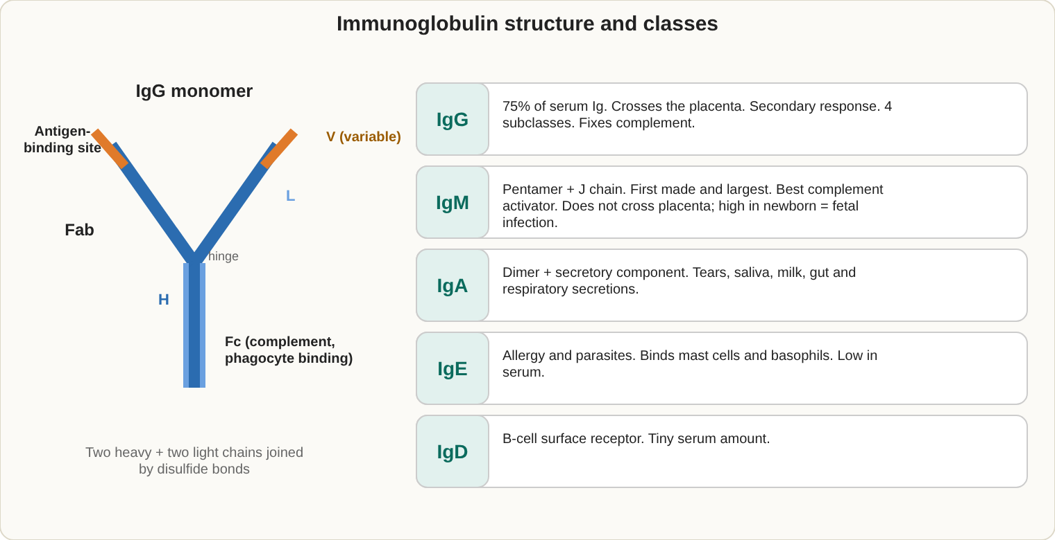
Antibody structure and the five classes.

Immunoglobulins
Class | Key facts
IgG | About 75% of serum antibody; crosses the placenta; main secondary (memory) response; IgG1 and IgG3 fix complement best
IgM | First antibody made; pentamer; best agglutinator and complement fixer; does not cross the placenta; high in newborn infection
IgA | Secretory form is a dimer with a J chain and secretory piece; found in saliva, tears and milk
IgE | Allergy and parasites; binds mast cells and basophils; lowest concentration
IgD | B cell surface receptor
- Structure: 2 heavy and 2 light chains. Fab binds antigen; Fc binds complement and Fc receptors. Papain gives 2 Fab and 1 Fc; pepsin gives F(ab')2.
- Primary response: slow, mostly IgM, low level. Secondary response: fast, mostly IgG, higher and longer.

Immune cells and markers
- T cells: CD3. Helper = CD4 (HLA class II). Cytotoxic = CD8 (HLA class I). Regulatory T cells = CD4, CD25, FOXP3.
- B cells: CD19, CD20, CD21; become plasma cells.
- NK cells: CD16, CD56; kill without prior exposure.
- Flow cytometry: forward scatter = size; side scatter = granularity. CD4 count follows HIV; CD34 counts stem cells.
- MHC: class I (A, B, C) on all nucleated cells; class II (DR, DP, DQ) on antigen-presenting cells.
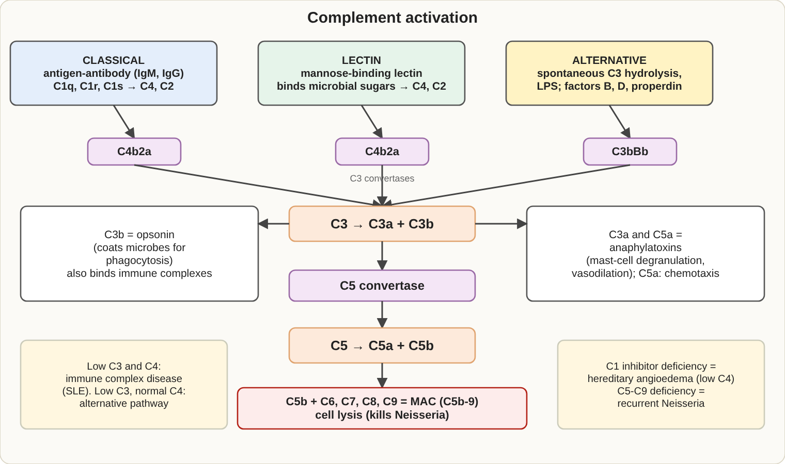
The three complement pathways meet at C3.

Complement
Pathway | Trigger | Key steps
Classical | Antibody bound to antigen (IgM, IgG) | C1q, then C4, C2, C3; convertase C4b2a
Alternative | Microbial surfaces | Factors B and D, properdin; convertase C3bBb
Lectin | Mannose-binding lectin | Joins at C4 and C2
- All pathways finish with the membrane attack complex, C5b-9.
- C3a, C4a and C5a are anaphylatoxins. C5a is a strong chemotaxin. C3b is the opsonin.
- Low C4 with C1 inhibitor deficiency = hereditary angioedema. Low C3 and C4 = immune complex disease (SLE, post-strep glomerulonephritis). Low C3 only = alternative pathway. Missing C5-C9 = repeated Neisseria infections.
- CH50 tests the whole classical pathway. Serum must be fresh or frozen; heating at 56 degrees C for 30 minutes destroys complement.

Hypersensitivity (ACID)
Type | Mechanism | Examples
I (Anaphylactic) | IgE on mast cells, immediate | Allergy, asthma, anaphylaxis; total IgE and specific IgE tests
II (Cytotoxic) | Antibody against cells, complement | Transfusion reactions, HDFN, autoimmune hemolytic anemia, Goodpasture, myasthenia gravis
III (Immune complex) | Antigen-antibody complexes deposit in tissue | SLE, serum sickness, Arthus reaction, glomerulonephritis
IV (Delayed) | T cells, 48-72 hours, no antibody | TB skin test, contact dermatitis, graft rejection

Immunodeficiency
Disorder | Clue
DiGeorge | No thymus, low T cells
Bruton agammaglobulinemia | X-linked, no B cells, low immunoglobulins
SCID | Both T and B cells missing
Selective IgA deficiency | Most common; risk of anaphylaxis from IgA-containing blood
Chronic granulomatous disease | NBT test negative (no respiratory burst)
Wiskott-Aldrich | Eczema, low platelets, infections
HIV | CD4 depletion
HIV testing: screen with a 4th-generation antigen/antibody test, then confirm with an HIV-1/HIV-2 differentiation immunoassay and NAT; viral load by RT-PCR. Western blot is no longer the first confirmation step.

Autoimmune disease markers
Disease | Key markers
SLE | ANA (screen), anti-dsDNA and anti-Smith (specific), low C3 and C4
Drug-induced lupus | Anti-histone
Sjogren | Anti-SSA (Ro), anti-SSB (La)
Diffuse scleroderma | Anti-Scl-70
CREST | Anti-centromere
Mixed connective tissue disease | Anti-U1 RNP
Rheumatoid arthritis | RF; anti-CCP is more specific
Celiac disease | Anti-tissue transglutaminase IgA, anti-endomysial IgA
Primary biliary cholangitis | Anti-mitochondrial
Autoimmune hepatitis | Anti-smooth muscle, ANA
Pernicious anemia | Anti-intrinsic factor, anti-parietal cell
Myasthenia gravis | Anti-acetylcholine receptor
Goodpasture | Anti-glomerular basement membrane
GPA (Wegener) | c-ANCA (PR3)
Microscopic polyangiitis | p-ANCA (MPO)
Graves disease | TSH receptor antibodies
Hashimoto thyroiditis | Anti-TPO, anti-thyroglobulin
Type 1 diabetes | Anti-GAD, anti-islet cell
ANA patterns: homogeneous (dsDNA, histone); speckled (Sm, RNP, SSA, SSB); nucleolar (scleroderma); centromere (CREST); rim or peripheral (dsDNA, very specific for SLE).
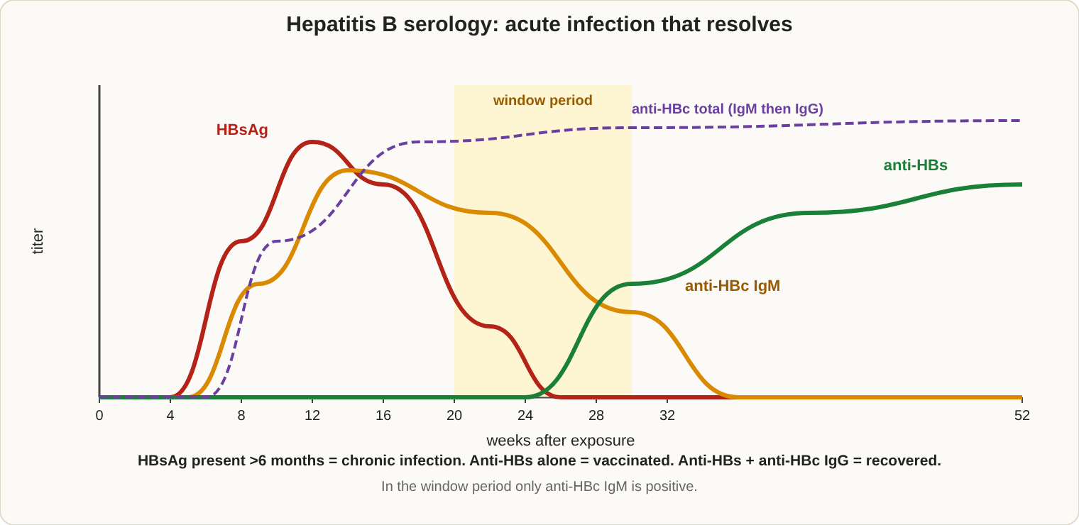
Typical hepatitis B markers in acute infection that resolves.

Infectious disease serology
Hepatitis B markers
Marker | What it means
HBsAg | Infection (acute or chronic); first marker to appear
Anti-HBs | Immunity from vaccine or recovery
Anti-HBc IgM | Acute infection, including the window period
Anti-HBc total | Past or present infection
HBeAg | High infectivity
- Vaccinated person: anti-HBs only.
- Hepatitis A: anti-HAV IgM = acute; IgG = past or vaccinated. Hepatitis C: antibody screen, then HCV RNA. Hepatitis D needs hepatitis B to infect.
- EBV: the Monospot (heterophile) antibodies are IgM and are absorbed by beef cells but not guinea pig kidney. EBV VCA IgM = acute; EBNA = past infection.
- Syphilis: nontreponemal tests (RPR, VDRL) detect reagin and are used for screening and to follow treatment; biologic false positives occur in SLE, pregnancy, mononucleosis, IV drug use. Treponemal tests (FTA-ABS, TP-PA, EIA) confirm and stay positive for life. VDRL is the only one accepted on CSF. Prozone effect: very high antibody gives a false negative until the serum is diluted.
- Rubella: IgG = immunity; IgM = acute. TORCH = toxoplasmosis, other, rubella, CMV, herpes.
- Strep antibodies: ASO and anti-DNase B, for rheumatic fever and glomerulonephritis.
- Lyme disease: two-tier testing (EIA then Western blot or second EIA).
- Fungal: cryptococcal antigen, histoplasma antigen, Aspergillus galactomannan.
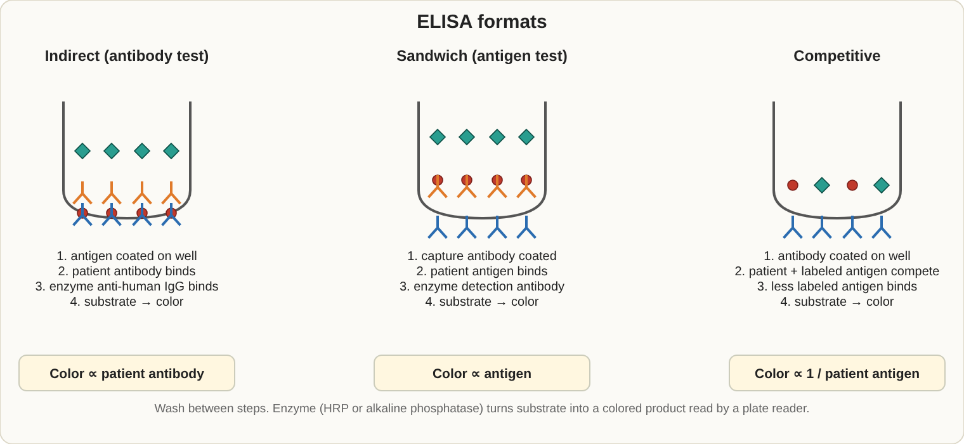
Three common ELISA formats and how the signal behaves.

Serologic techniques
Technique | Principle
Precipitation | Antibody and antigen form a lattice at equivalence; Ouchterlony shows identity; radial immunodiffusion measures IgG, IgM, IgA
Agglutination | Visible clumping; prozone = too much antibody; postzone = too much antigen
ELISA | Enzyme-labeled antibody. Sandwich for antigens, indirect for antibody. Competitive assays give a lower signal with more analyte
Western blot | Proteins separated by size, transferred to a membrane, detected with labeled antibody
Immunofluorescence | Direct (labeled antibody on antigen) or indirect (labeled anti-IgG); used for ANA
Nephelometry | Light scatter measures proteins and immunoglobulins
Immunofixation | Identifies monoclonal proteins
- Positive predictive value goes up when disease prevalence goes up.
- Monoclonal antibodies are made by hybridoma technology.

Transplantation
- HLA matching: A, B and DR matter most. A crossmatch finds preformed antibodies that would cause hyperacute rejection.
- Acute rejection is T-cell mediated (days to weeks); chronic rejection takes months to years.
- Graft-versus-host disease: donor lymphocytes attack an immunocompromised host.

Innate and adaptive immunity
- Innate (immediate, non-specific): neutrophils, macrophages, NK cells, complement, skin barriers. Phagocytosis is helped by opsonins (IgG, C3b). The NBT test checks the neutrophil respiratory burst.
- Adaptive (slower, specific, with memory): T and B lymphocytes.
- Antigen terms: an epitope is the part of an antigen an antibody binds; a hapten is a small molecule that triggers a response only when attached to a carrier (as in penicillin allergy).
- Acute phase proteins: CRP rises within 4-6 hours and peaks at 36-50 hours (high-sensitivity CRP estimates heart disease risk); ferritin, fibrinogen and haptoglobin also rise. Albumin falls.

Cytokines
Cytokine | Main role
IL-1, TNF-alpha | Fever and inflammation
IL-2 | Growth of T cells
IL-4, IL-5 | B cell and eosinophil growth, allergy
IL-6 | Acute phase response, CRP production
IL-8 | Attracts neutrophils
Interferon-gamma | Activates macrophages; basis of the TB blood test
Cytokines are measured by ELISA, multiplex bead assays or flow cytometry.

Monoclonal gammopathies
Condition | Key points
MGUS | Small monoclonal protein, under 10% plasma cells, no organ damage
Multiple myeloma | Over 10% plasma cells, M-protein, bone lesions, kidney damage, high calcium
Waldenstrom macroglobulinemia | IgM paraprotein, thick blood (hyperviscosity)
Cryoglobulinemia | Proteins that precipitate in the cold; keep the sample at 37 degrees C
Amyloidosis | Light-chain protein deposits
Serum protein electrophoresis finds the spike; immunofixation identifies the heavy and light chain type.

Stages of syphilis and Lyme disease
Disease | Stage | What happens
Syphilis | Primary | Painless chancre; nontreponemal tests may still be negative
Syphilis | Secondary | Rash (including palms and soles), condylomata lata; tests strongly positive
Syphilis | Latent | No symptoms; positive tests
Syphilis | Tertiary | Gummas, heart and brain damage
Lyme | Early localized | Erythema migrans rash, tick bite
Lyme | Early disseminated | Heart block, facial palsy, meningitis; antibodies positive
Lyme | Late | Arthritis, nerve problems

Tuberculosis testing
- PPD (tuberculin skin test): a delayed (type IV) reaction read at 48-72 hours; measure the hardened area, not the redness. Positive at 5 mm or more in high-risk people (HIV, close contacts), 10 mm or more in moderate-risk people, and 15 mm or more in low-risk people.
- Interferon-gamma release assays (QuantiFERON, T-SPOT): blood tests that are not affected by BCG vaccination and need only one visit.

More viral serology
Virus | Key points
HIV | Earliest: HIV RNA, then p24 antigen, then antibodies (4th-generation tests find antigen and antibody)
CMV | IgM = recent infection; IgG alone = past; high avidity IgG = infection over 3 months old
Measles, mumps, rubella | IgM = acute; IgG = immunity
Parvovirus B19 | IgM indicates recent infection
West Nile virus | IgM in serum or CSF; NAT in blood donors

Thyroid antibodies, ANA and rheumatoid factor
- Thyroid: anti-TPO and anti-thyroglobulin (Hashimoto); TSH receptor antibodies (Graves).
- Rheumatoid factor (RF): IgM against the Fc part of IgG; also positive in other diseases and some healthy older adults; anti-CCP is more specific for rheumatoid arthritis.
- ANA: screened by indirect immunofluorescence on HEp-2 cells; positive at a titer of 1:40 or 1:80 or higher depending on the lab, then reflexed to specific antibody tests.

Exam traps
- IgM, not IgG, is the first antibody and the best complement activator.
- Type IV hypersensitivity involves T cells, not antibody.
- Treponemal tests stay positive for life; nontreponemal tests fall with treatment.
- Anti-dsDNA is specific for SLE; ANA alone is a sensitive screen but not specific.

6. Urinalysis and Body Fluids (5-10%)
If you only remember 8 things
- Test urine within 2 hours or refrigerate. Left standing, pH rises, glucose and ketones fall, and cells and casts break down.
- A positive dipstick blood with no red cells under the microscope = hemoglobin or myoglobin.
- Nitrite and leukocyte esterase together suggest a bacterial urinary infection.
- The dipstick is most sensitive to albumin; sulfosalicylic acid (SSA) detects all proteins, including Bence Jones.
- Casts: RBC cast = glomerulonephritis; WBC cast = pyelonephritis; fatty cast = nephrotic syndrome; waxy cast = chronic kidney failure.
- Acid urine crystals: uric acid, calcium oxalate, cystine. Alkaline urine crystals: triple phosphate (coffin lid), ammonium biurate, amorphous phosphate.
- CSF tubes: tube 1 chemistry, tube 2 microbiology, tube 3 cell count. Never refrigerate CSF for culture.
- Gout crystals are needle-shaped with strong negative birefringence; pseudogout crystals are rhomboid with weak positive birefringence.

Specimen handling
- First morning: most concentrated, best for protein, nitrite and pregnancy tests. Midstream clean catch: culture. Timed 24-hour: discard the first void, collect everything after, include the last void at the end.
- Unpreserved urine changes: bacteria multiply, pH rises (urea splitting makes ammonia), urobilinogen turns to urobilin, glucose and ketones fall, cells and casts dissolve.
- Preservatives: boric acid, thymol, formalin (cells and casts), sodium fluoride.

Physical examination
Finding | Usual cause
Dark yellow, foam yellow when shaken | Bilirubin
Red and cloudy | Red cells
Red and clear | Hemoglobin, myoglobin, porphyrins, beets
Brown or black | Melanin, old blood, homogentisic acid (darkens on standing)
Port wine | Porphyrins
Blue-green | Pseudomonas, methylene blue
Milky | Fat (chyle), pus, amorphous phosphates
Cloudy | Cells, bacteria, mucus, amorphous urates (pink, acid) or phosphates (white, alkaline)
- Specific gravity: refractometer measures dissolved solids directly; dipstick reads ionic strength; osmolality is the best true measure. Normal 1.003-1.035. A fixed value near 1.010 (isosthenuria) suggests severe kidney damage.
- Odor: fruity = ketones; maple syrup = maple syrup urine disease; mousy = phenylketonuria; ammonia = old specimen or infection.

Chemical examination (dipstick)
Test | Principle | Key points
Glucose | Glucose oxidase | Positive in diabetes or when the renal threshold (about 160-180 mg/dL) is exceeded; vitamin C gives a false negative; Clinitest detects other reducing sugars
Ketones | Nitroprusside | Acetoacetate and acetone, not beta-hydroxybutyrate
Protein | Protein error of indicators | Albumin most; false positive in alkaline urine; misses Bence Jones
Blood | Pseudoperoxidase | Red cells, hemoglobin, myoglobin; vitamin C false negative
Bilirubin | Diazo | Conjugated bilirubin only; light destroys it
Urobilinogen | Ehrlich | High in hemolysis and liver disease; absent in complete blockage
Nitrite | Greiss | Gram-negative bacteria; needs about 4 hours in the bladder; false negative with vitamin C
Leukocyte esterase | Esterase from neutrophils | Pyuria; does not detect lymphocytes
pH | Methyl red and bromthymol blue | Range 4.5-8.0
- Hemoglobin vs myoglobin: both give a positive blood pad without red cells. Hemoglobinuria comes with pink plasma; myoglobinuria has clear plasma (muscle injury, rhabdomyolysis).
- Ascorbic acid interferes with glucose, blood, bilirubin, nitrite and leukocyte esterase.
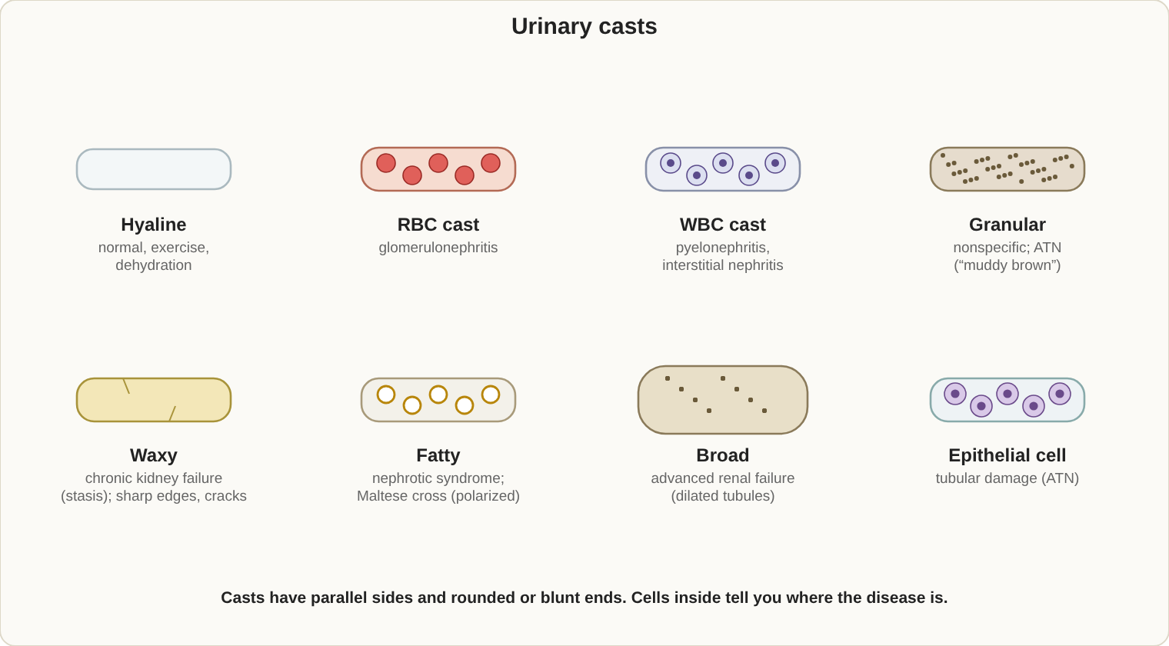
Urine casts: cylinders formed in the distal tubule from Tamm-Horsfall protein.

Microscopic examination
- Spin 10-12 mL at 400 RCF for 5 minutes, leave 0.5-1 mL, resuspend. Report casts per low-power field and cells per high-power field.
- Stains: Sternheimer-Malbin (cells, casts), Hansel (eosinophils), Sudan III or Oil Red O (fat), Prussian blue (iron).
- Phase microscopy helps see hyaline casts and mucus; polarized light shows crystals and the Maltese cross of fat droplets.
Cell | Meaning
Red cells | Glomerular or lower tract bleeding; crenated in concentrated urine, ghosts in dilute
White cells | Infection or inflammation; glitter cells in dilute urine
Squamous epithelial cells | Contamination
Transitional cells | Bladder or catheter
Renal tubular cells | Tubular injury (acute tubular necrosis)
Oval fat bodies | Fat in urine; nephrotic syndrome

Casts (formed in the distal tubule from Tamm-Horsfall protein)
Cast | Meaning
Hyaline | Normal in small numbers; exercise, dehydration
Red cell | Glomerular bleeding, glomerulonephritis
White cell | Pyelonephritis, interstitial nephritis
Epithelial cell | Tubular damage
Granular | Nonspecific; stasis
Waxy | Severe stasis, chronic kidney failure
Fatty | Nephrotic syndrome
Broad | Dilated tubules, chronic kidney failure
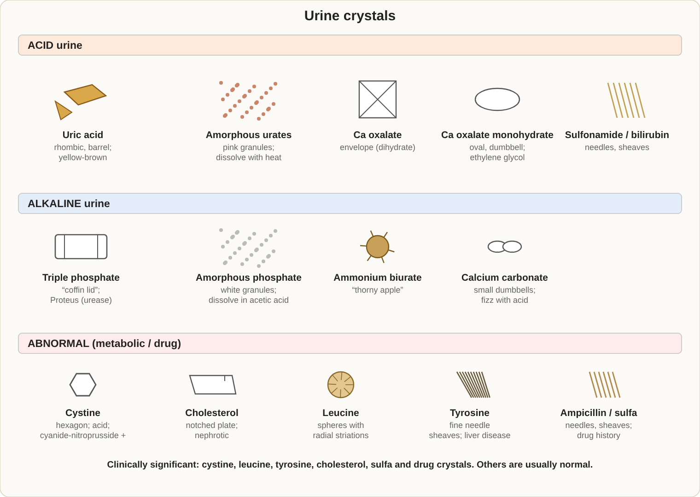
Urine crystals by pH, and the abnormal ones to know.

Crystals
Urine pH | Crystal | Look and meaning
Acid | Uric acid | Yellow-brown rhombic or rosette; polarizes
Acid | Calcium oxalate | "Envelope" shape; dumbbell form; ethylene glycol poisoning
Acid | Cystine | Colorless hexagons; cystinuria; cyanide-nitroprusside test
Acid | Leucine and tyrosine | Spheres and fine needles; liver disease
Acid | Cholesterol | Notched plates
Acid | Sulfonamide, bilirubin | Sheaves, needles
Alkaline | Triple phosphate (struvite) | "Coffin lid"; urea-splitting bacteria (Proteus)
Alkaline | Ammonium biurate | Yellow-brown "thorny apple"
Alkaline | Calcium phosphate, carbonate | Prisms, plates, dumbbells (carbonate fizzes with acid)
Alkaline | Amorphous phosphate | White precipitate
- Other findings: yeast (buds, no rim, may mimic red cells), Trichomonas (jerky motility), sperm, mucus, Schistosoma haematobium eggs.

Kidney disease patterns
Syndrome | Urine findings
Nephrotic | Protein above 3.5 g/day, oval fat bodies, fatty and waxy casts, low albumin, high lipids
Nephritic (glomerulonephritis) | Blood, red cell casts, mild protein, high blood pressure
Pyelonephritis | White cell casts, bacteria
Cystitis | White cells and bacteria, no casts
Acute tubular necrosis | Tubular cells and granular casts
- Creatinine clearance (mL/min) = (urine creatinine x urine volume per minute / plasma creatinine) x (1.73 / body surface area). Normal about 90-120.
- Inherited metabolic disorders in urine: phenylketonuria (ferric chloride turns green), alkaptonuria (black on standing), maple syrup urine disease, cystinuria, porphyria (Ehrlich, Watson-Schwartz).
- Urine pregnancy test (hCG): first-morning urine is most concentrated; a very high hCG can cause a false negative (hook effect).
- Drug testing: immunoassay screen with GC/MS confirmation; check temperature (90-100 F within 4 minutes), specific gravity, creatinine and pH; chain of custody required.
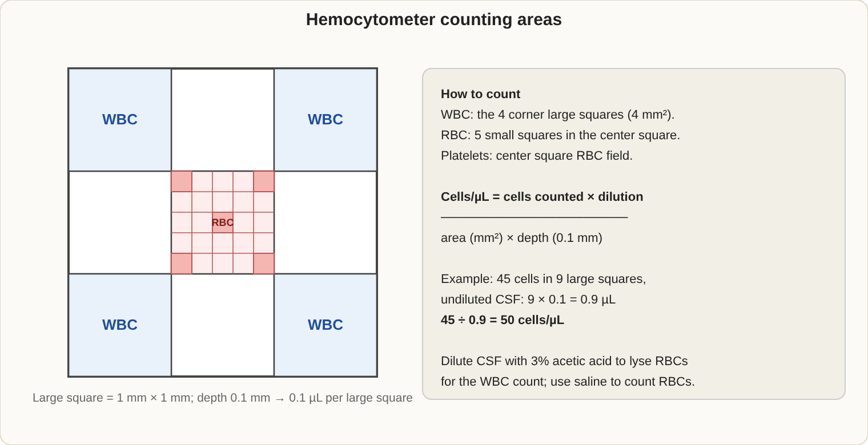
Neubauer hemocytometer and the counting formula.

Cerebrospinal fluid (CSF)
- Three tubes: 1 = chemistry and serology; 2 = microbiology; 3 = cell count (least likely to have blood from the puncture).
- Normal: clear, colorless; white cells 0-5 per microliter in adults; glucose about 60-70% of plasma glucose; protein 15-45 mg/dL.
- Traumatic tap: blood clears from tube 1 to tube 3, supernatant is clear, clots may form. Bleeding into the brain space: equal blood in all tubes and a yellow supernatant (xanthochromia).
Cause | Appearance | Cells | Protein | Glucose
Bacterial meningitis | Cloudy | Neutrophils | High | Low
Viral meningitis | Clear | Lymphocytes | Normal or mild increase | Normal
Fungal or tuberculous | Clear or cloudy | Lymphocytes, monocytes | High | Low
- Cell counts: dilute with saline for red cells; use acetic acid-methylene blue to lyse red cells for white cell counts. Cytospin slides give the differential.
- Other tests: India ink (Cryptococcus), Gram stain and culture, VDRL (neurosyphilis), oligoclonal bands (multiple sclerosis).

Other body fluids
Fluid | Key facts
Serous (pleural, pericardial, peritoneal) | Exudate (infection, cancer) if any one: fluid/serum protein above 0.5, fluid/serum LD above 0.6, or fluid LD above two thirds of the serum upper limit. Otherwise transudate (heart failure, cirrhosis, nephrotic)
Synovial | Normal: clear, viscous, white cells below 200 per microliter. Septic: very high white cells, low glucose, positive culture
Peritoneal | SAAG at or above 1.1 g/dL = portal hypertension (cirrhosis). More than 250 neutrophils per microliter = spontaneous bacterial peritonitis
Amniotic | L/S ratio of 2.0 or more = fetal lung maturity; alpha-fetoprotein high in neural tube defects; protect from light
Semen | Typical lower limits (WHO 2010): volume 1.5 mL, count 15 million/mL, motility 40%, normal forms 4%. Liquefies in 30-60 minutes; examine within 1 hour. After vasectomy: no sperm
Feces | Occult blood (guaiac), fecal fat (Sudan III), fecal white cells
Joint crystals
Crystal | Shape | Birefringence | Disease
Monosodium urate | Needle | Strong negative (yellow when parallel to the compensator axis) | Gout
Calcium pyrophosphate | Rhomboid | Weak positive (blue when parallel) | Pseudogout
Hemocytometer counting: cells per microliter = (cells counted x dilution factor) / (area counted in mm squared x depth 0.1 mm). Count both chambers and compare.

Kidney physiology in brief
Part of the nephron | What it does
Glomerulus | Filters plasma (about 125 mL/min); keeps large proteins and cells in the blood
Proximal tubule | Reabsorbs about two thirds of filtrate: glucose, amino acids, sodium, water
Loop of Henle | Builds the concentration gradient (countercurrent mechanism)
Distal tubule and collecting duct | Fine control: ADH makes urine concentrated, aldosterone saves sodium and loses potassium
- Renal threshold: the blood level above which a substance spills into urine (glucose about 160-180 mg/dL).
- Diabetes insipidus: lots of very dilute urine (low specific gravity) from too little ADH or kidney resistance to it.
- Concentration test: a kidney that cannot concentrate urine after water restriction points to tubular damage.
- Orthostatic proteinuria: protein in daytime urine but not in the first morning sample; usually harmless in young people.
- Kidney stones, urinary tract infection, renal tubular acidosis, Fanconi syndrome and diabetic kidney disease are the common disease states.

Confirmatory urine tests
Test | Confirms
Sulfosalicylic acid (SSA) | Total protein, including globulins and Bence Jones
Clinitest (copper reduction) | Reducing sugars such as galactose, lactose, fructose
Ictotest (tablet) | Bilirubin
Acetest (tablet) | Ketones
Ferric chloride | Phenylketonuria (green), other metabolites
Hoesch or Watson-Schwartz | Porphobilinogen
Cyanide-nitroprusside | Cystine

More about body fluids
- Serous fluids: lymphocytes suggest tuberculosis or cancer; a low pH (below 7.2) points to a pus-filled infection (empyema); cloudy-white fluid from a leaking lymph duct is chylous (triglycerides above 110 mg/dL), while pseudochylous fluid is rich in cholesterol.
- Synovial fluid groups: noninflammatory (osteoarthritis), inflammatory (rheumatoid arthritis, gout), septic (bacterial infection), hemorrhagic (trauma, hemophilia). Viscous fluid is treated with hyaluronidase before counting.
- CSF IgG index and oligoclonal bands help diagnose multiple sclerosis.
- Feces: the immunochemical test (FIT) detects human globin and is more specific than the guaiac test, which can react to red meat or vitamin C. Qualitative fecal fat (Sudan III) screens for steatorrhea; elastase tests the pancreas.
- Semen extras: fructose is made by the seminal vesicles (absent in blocked ducts); vitality is checked with eosin-nigrosin stain; normal strict morphology is 4% or more; antisperm antibodies cause clumping.

Exam traps
- Nitrite can be negative with a real infection (Enterococcus, short bladder time, vitamin C).
- Dipstick protein misses Bence Jones protein and globulins.
- A traumatic CSF tap clears; true hemorrhage does not.
- Yeast and red cells look alike; yeast buds and does not dissolve in acetic acid.

7. Laboratory Operations (5-10%)
If you only remember 8 things
- Accuracy = closeness to the true value (bias). Precision = repeatability (SD, CV).
- A shift = 6 or more points on one side of the mean (systematic error). A trend = 6 or more points steadily moving in one direction.
- Westgard: 1-2s is a warning; 1-3s and R-4s mean random error; 2-2s, 4-1s and 10x mean systematic error. When QC fails, do not report patient results.
- CLIA sets the federal law; CAP and The Joint Commission accredit; OSHA covers worker safety; CLSI writes standards.
- Standard precautions: treat all blood and body fluids as infectious; never recap needles.
- Disinfect blood spills with a fresh 1:10 bleach dilution.
- Order of draw: blood culture, light blue, red or gold, green, lavender, gray.
- Most laboratory errors happen before the test (preanalytic): wrong tube, mislabeling, poor collection.
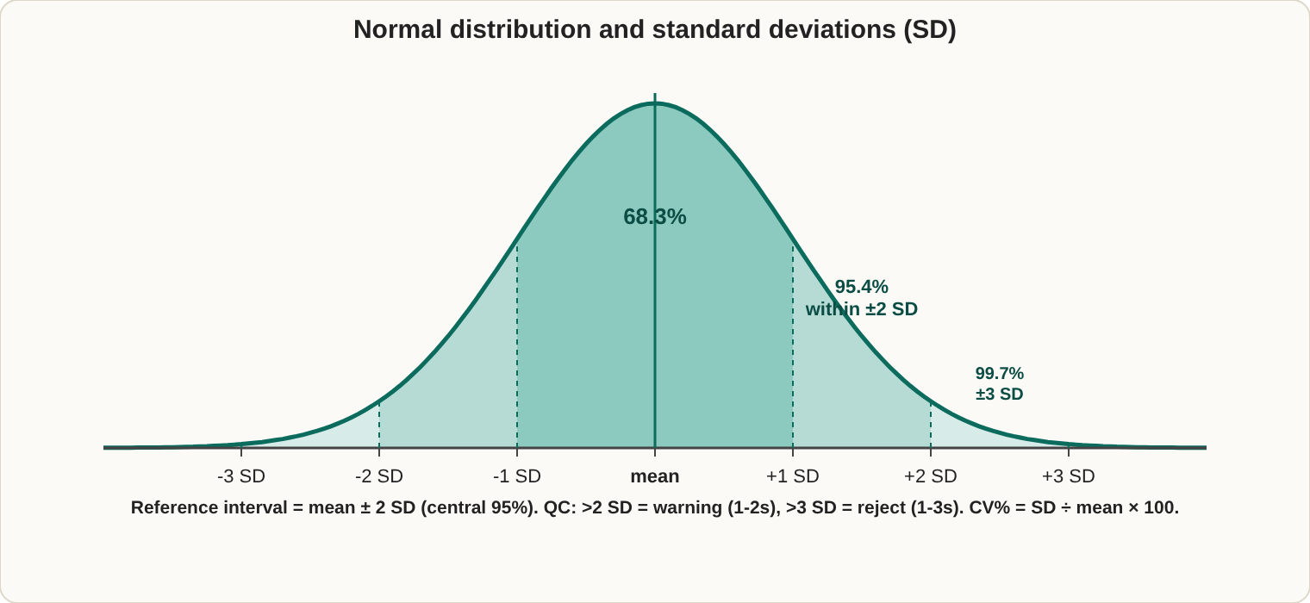
The normal distribution: where QC limits and reference ranges come from.
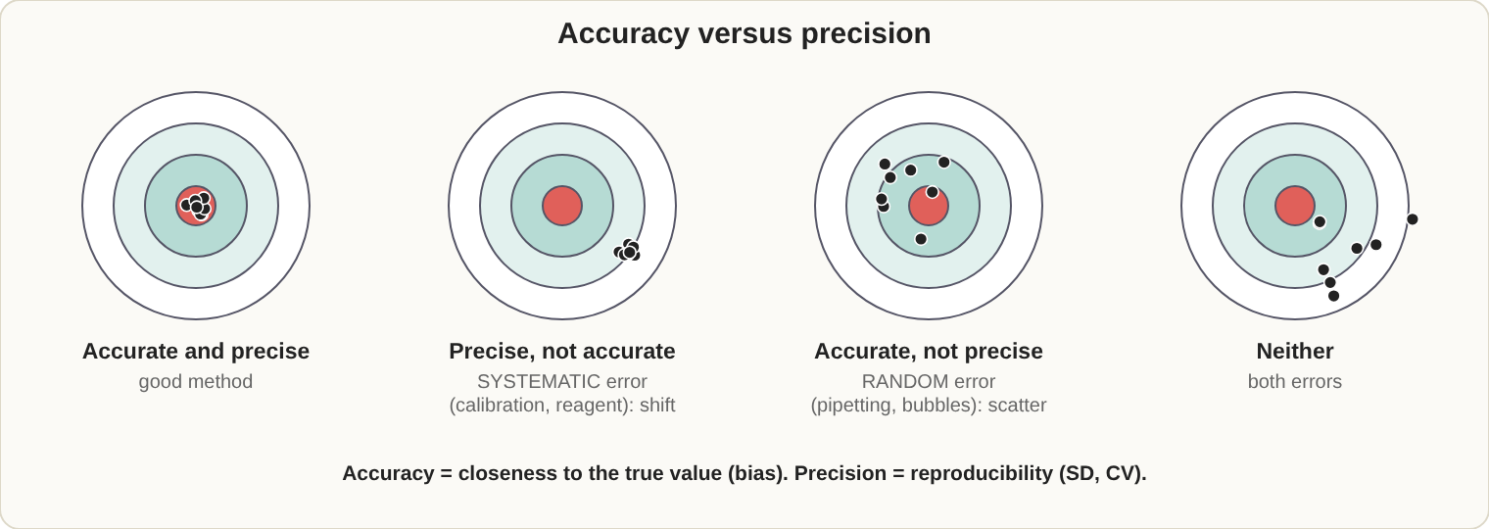
Accuracy and precision. Systematic error shifts the mean; random error widens the scatter.

Quality control statistics
- Mean = sum / n. Standard deviation (SD) shows spread. Coefficient of variation (CV%) = (SD / mean) x 100.
- Within 1 SD = 68% of values; within 2 SD = 95%; within 3 SD = 99.7%.
- Run at least 2 levels of control each day. Plot on a Levey-Jennings chart.
- Reference ranges usually cover the middle 95% of healthy people (mean +/- 2 SD), so about 5% of healthy people fall outside.
Pattern on the chart | What it means | Common causes
Shift | Systematic error | New reagent lot, calibration change, maintenance
Trend | Systematic error, gradual | Aging reagent, light source, temperature drift
Scatter | Random error | Pipetting, bubbles, mixing

Westgard rule | Meaning | Action
1-2s | One control beyond 2 SD | Warning only
1-3s | One control beyond 3 SD | Reject (random error)
2-2s | Two controls beyond the same 2 SD | Reject (systematic error)
R-4s | One above +2 SD and one below -2 SD | Reject (random error)
4-1s | Four in a row beyond 1 SD on one side | Reject (systematic error)
10x | Ten in a row on one side of the mean | Reject (systematic error)
- When QC fails: stop, do not report patient results, troubleshoot, repeat the control, recalibrate if needed, and recheck patient samples run since the last good QC.
- New control lots are run alongside the old lot to set a mean (at least 20 data points).
- Method verification: precision, accuracy, reportable range, reference interval. Delta checks compare today's result with the last one to catch mix-ups.
- Sensitivity, specificity and predictive values are defined in the Immunology section.

Regulations and organizations
Organization | Role
CLIA '88 (CMS) | Federal law for all human lab testing: complexity levels, proficiency testing, personnel
CAP | Accredits laboratories; inspects
The Joint Commission | Accredits hospitals including their labs
COLA | Accredits physician office labs
FDA | Clears tests, reagents and blood products
OSHA | Worker safety: bloodborne pathogens, chemical hygiene
CLSI | Consensus standards and guidelines
AABB | Blood bank and transfusion standards
CDC | Surveillance and infection control guidance
ISO 15189 | International standard for medical labs
- Proficiency testing (PT): unknown samples from an approved provider, 3 events a year, 5 samples per event. A satisfactory score is 80% (100% for ABO and Rh). Treat PT samples like patient samples and never send them to another lab.
- Waived tests (urine dipstick, glucose meters, rapid strep) need only a certificate of waiver and following the manufacturer's directions.
- Typical record retention (US, check your local rules): patient test and QC records 2 years; blood bank records 5 years or longer; pathology reports 10 years.
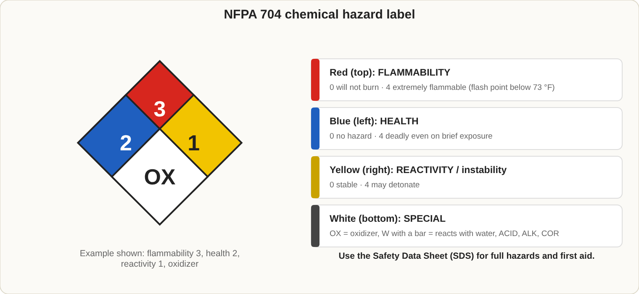
NFPA 704 hazard diamond. Ratings run from 0 (none) to 4 (severe).

Safety
- Standard precautions: gloves, gown and face protection when splashes are possible; wash hands after removing gloves; do not recap needles; sharps containers are puncture-proof and never filled more than two thirds.
- Hand hygiene: use soap and water for visibly dirty hands and after contact with C. difficile; alcohol rub is fine otherwise.
- Bloodborne pathogens (OSHA): hepatitis B vaccine offered free within 10 days of hire; exposure control plan reviewed every year.
- Spills: wear gloves, cover with absorbent paper, apply fresh 1:10 bleach (about 0.5% hypochlorite) for at least 10 minutes, wipe, discard as biohazard.
Biosafety level | Typical agents
BSL-1 | No known disease risk
BSL-2 | Standard clinical lab: S. aureus, Salmonella, hepatitis B
BSL-3 | Airborne agents: M. tuberculosis cultures, Brucella, Coccidioides
BSL-4 | Exotic, life-threatening: Ebola
- Chemicals: every chemical needs a Safety Data Sheet (SDS). NFPA diamond: blue = health, red = flammability, yellow = reactivity, white = special. Always add acid to water. Store acids and bases apart; flammables in safety cabinets. Flush eyes for 15 minutes.
- Fire: RACE = rescue, alarm, contain, extinguish. PASS = pull, aim, squeeze, sweep. Class A ordinary materials, B flammable liquids, C electrical, D metals.
- Waste: biohazard bags go to the autoclave (121 degrees C, 15 psi, 30 minutes or longer); sharps in rigid containers; chemical waste by hazard class.
- Shipping: infectious substances need triple packaging (Category A = UN2814, Category B = UN3373).

Specimen collection (preanalytic)
Order of draw (CLSI): 1) blood culture bottles, 2) light blue (citrate), 3) red or gold (serum), 4) green (heparin), 5) lavender (EDTA), 6) gray (fluoride).
- Identify the patient with two identifiers and label at the bedside.
- Tourniquet for less than 1 minute. Fist pumping raises potassium. Hemolysis raises K, LD, AST, phosphate and magnesium.
- Avoid arms with an IV, hematoma, mastectomy, or fistula.
- Capillary sticks: infant heel (2 mm or less in depth), fingertip side of the 3rd or 4th finger; wipe away the first drop; EDTA is drawn first in a capillary collection.
- Fasting: 8-12 hours for glucose and lipids.
Specimen | Handling
Ammonia, lactate, blood gas, ACTH | On ice
Bilirubin | Protect from light
Cold agglutinins, cryoglobulins | Keep warm at 37 degrees C
Potassium | Do not refrigerate before separation
Serum or plasma | Separate within 2 hours
- Reject specimens that are unlabeled or mislabeled, the wrong tube, clotted (EDTA), too little volume, delayed, or contaminated.
- Chain of custody documents each person who handles a legal specimen (for example drug testing).
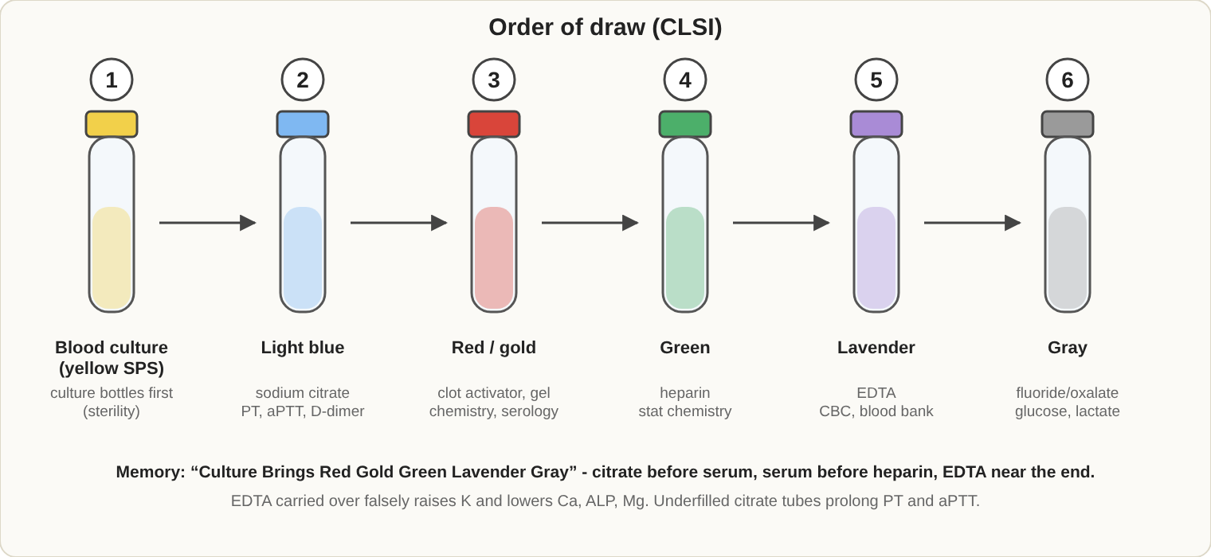
CLSI order of draw. Wrong order carries additives into the next tube.

Math and reagents
- Dilution = sample volume / total volume. Serial dilutions multiply (1:2 then 1:5 = 1:10). C1 x V1 = C2 x V2.
- Percent solution (w/v) = grams per 100 mL. Molarity = moles per liter. Normality = equivalents per liter.
- Conversions: Celsius = (F - 32) x 5/9. Glucose mg/dL / 18 = mmol/L. Creatinine mg/dL x 88.4 = micromol/L.
- Temperatures: refrigerator 2-8 degrees C; freezer -20 degrees C or lower; incubator 35-37; room temperature 20-25. Record daily.
- Centrifuge: RCF = 1.118 x 10^-5 x radius (cm) x rpm squared. Check speed and timers regularly.
- Water types: Type I is the purest (reagents, trace metals); Type II for general lab use; Type III for rinsing glassware.
- Calibrate pH meters with at least 2 buffers.
- Pipettes: check accuracy and precision regularly; read the meniscus at eye level.

Management, ethics and information systems
- Quality assurance covers the whole testing process: preanalytic (collection), analytic (testing, QC) and postanalytic (reporting).
- Critical values must be called to the responsible clinician immediately with read-back, and documented with date, time and person notified.
- Quality tools: PDCA (plan, do, check, act), root-cause analysis, fishbone diagrams, Pareto charts.
- Competency assessment: at 6 months and 12 months for new staff, then annually. It includes direct observation, review of results and records, and testing of known samples.
- Procedure manuals: purpose, principle, specimen, reagents, procedure, calculations, reference ranges, limitations. Review annually.
- LIS: manages orders and results, links to instruments, applies autoverification rules and keeps an audit trail. HIPAA requires protecting patient information.
- Ethics: confidentiality, honest reporting, never falsify results, report errors, stay within scope of practice.
- Instruments: keep daily, weekly and monthly maintenance logs; verify after repairs; calibration verification at least every 6 months.
- Reagents: label with identity, date prepared, date opened, expiry and initials; check each new lot with QC before use; first in, first out.
- Point-of-care testing: waived tests, operator training, QC, and awareness of meter limits (for example hematocrit effects on glucose).
- Corrected reports: mark as corrected, keep the original, and notify the clinician.
- Cost: break-even point = fixed costs / (price per test - variable cost per test).
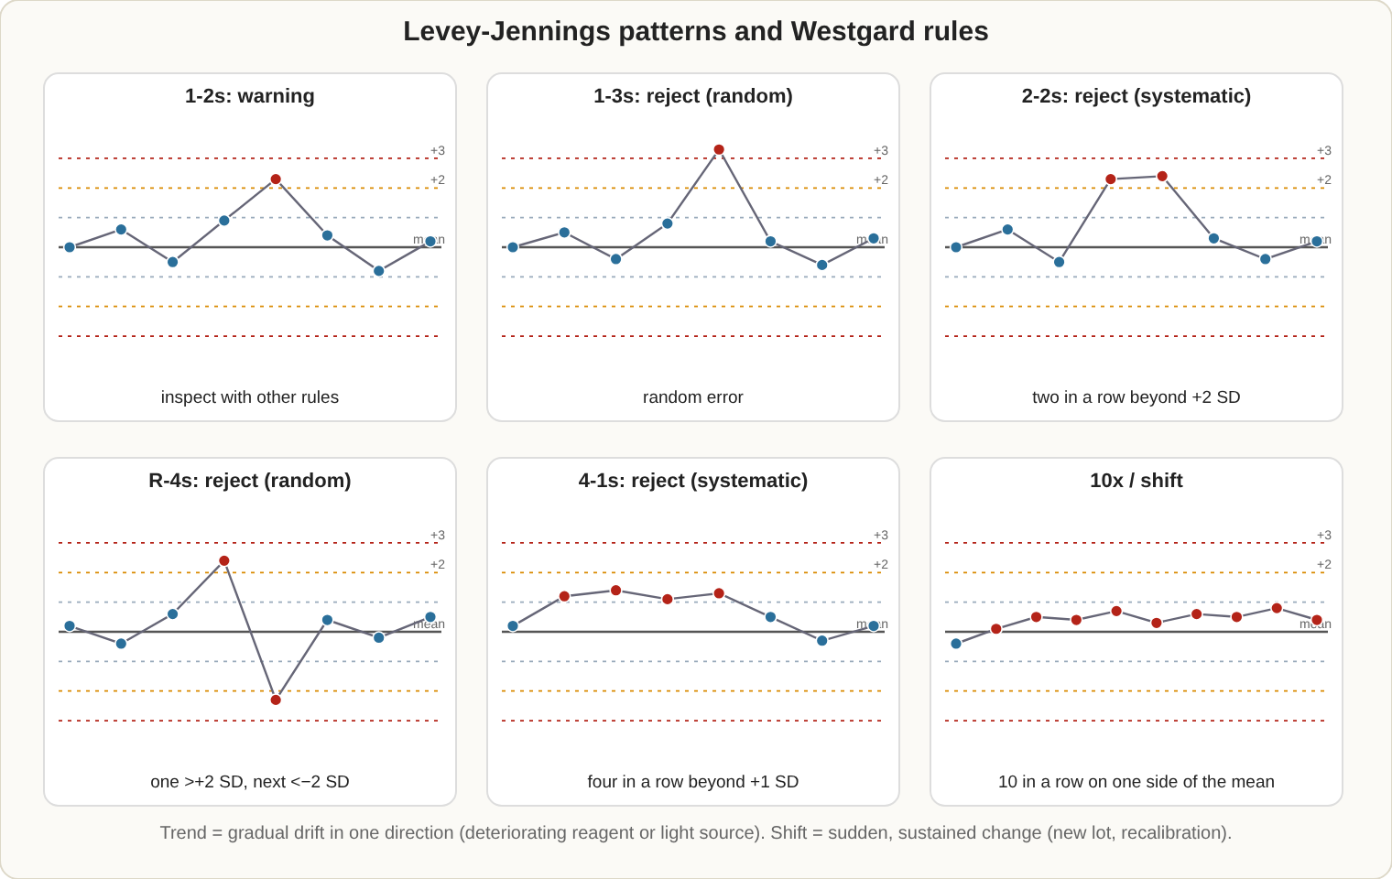
Levey-Jennings charts: how the Westgard rules look. Dotted lines are ±1, ±2 and ±3 SD.

Laboratory statistics
- Mean = average. Median = middle value when sorted. Mode = most frequent value. In a normal (bell-shaped) distribution they are about equal.
- 95% confidence interval = mean +/- 1.96 SD (about 2 SD).
- Correlation coefficient (r) shows how closely two methods agree (1.0 = perfect). In a method comparison regression, the slope shows proportional error and the intercept shows constant error.
- t-test compares two means (accuracy); F-test compares two standard deviations (precision).
- Standard curve: plot known concentrations against signal; read unknowns from the line.

Instruments and methods
Method | Principle and use
Spectrophotometry and photometry | Light absorbed by a colored solution is proportional to concentration (Beer's law)
Fluorometry | Measures emitted light at a different wavelength; very sensitive
Nephelometry and turbidimetry | Light scatter or blockage by particles; proteins, immunoglobulins
Osmometry | Freezing point depression measures total particles
Electrophoresis | Charged molecules move in an electric field; proteins, hemoglobin, isoenzymes
Chromatography (GC, HPLC, TLC) | Separates mixtures; drugs, toxins, vitamins
Mass spectrometry | Ionizes molecules and sorts them by mass-to-charge ratio; drug confirmation, newborn screening
Electrochemistry | Ion-selective electrodes (potentiometry) for Na, K, Cl, pH; Clark electrode (amperometry) for pO2; Severinghaus electrode for pCO2; coulometry for chloride
Flow cytometry | Cells in a stream pass a laser; scatter and fluorescence identify cell types
Hematology analyzers | Impedance (Coulter) counts and sizes cells; optical scatter and dyes give the differential
Automated microbiology | Continuous blood culture monitors; ID and susceptibility cards; MALDI-TOF
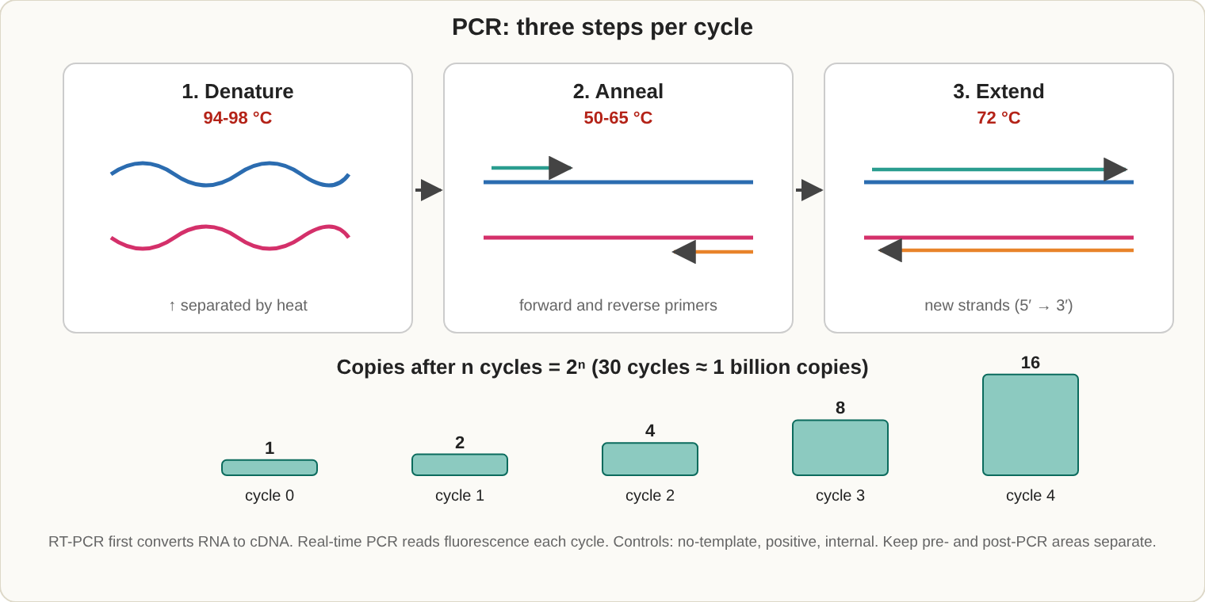
One PCR cycle, and why copy number doubles each time.

Molecular methods
Method | What it does
PCR | Copies DNA: denature (about 95 degrees C), anneal primers (50-65), extend (72), repeated for many cycles
RT-PCR | First converts RNA to DNA; used for viral RNA such as HIV and hepatitis C
Real-time (quantitative) PCR | Measures product each cycle; gives viral load
NAAT | Nucleic acid amplification tests such as Chlamydia and gonorrhea assays
FISH | Fluorescent probes find specific chromosome regions (for example BCR-ABL)
Sequencing | Reads the DNA order; 16S for bacteria
Southern, Northern, Western blot | Detect DNA, RNA and protein, in that order
Contamination (carryover) is the main risk; use separate rooms for reagent prep, sample prep and amplification, and include negative controls.

Emergency procedures
- Needlestick or cut: wash with soap and water at once, report immediately, and have the source patient and the worker evaluated; post-exposure treatment (for HIV) works best within hours.
- Splash to eyes, nose or mouth: flush with water or an eyewash for 15 minutes, then report.
- Chemical on skin: remove contaminated clothing and rinse with water for at least 15 minutes (use the safety shower for large areas).
- Fire: RACE and PASS (see Safety). Know where the alarms, exits, extinguishers and eyewash are.
- Spills: use the right spill kit for biological or chemical spills; mercury needs special cleanup.

Management principles
- Leaders set goals, communicate, delegate and handle conflict. Common styles are autocratic, democratic and laissez-faire.
- Budgeting: direct costs (reagents, supplies, labor) and indirect costs (rent, utilities). Productivity is tracked as tests per FTE (full-time equivalent).
- Inventory: first in, first out; set minimum (par) levels; track expiration dates.
- Hiring and evaluation: job descriptions, orientation, annual performance reviews, corrective discipline with documentation.
- Test selection: compare cost, turnaround time, accuracy and clinical value when adding a test.

Education principles
- Adults learn best when the material is relevant, practical and self-directed (andragogy).
- Good learning objectives are measurable. Learning has three domains: cognitive (knowledge), psychomotor (skills such as pipetting) and affective (attitudes).
- Teach by demonstrating, then letting the learner practice with supervision, then give prompt, specific feedback.
- Test learning with written questions, direct observation and competency checklists.

Exam traps
- A 1-2s violation is only a warning; 1-3s and R-4s signal random error.
- QC failing means do not report results, not repeat until it passes.
- Bleach for spills is 1:10, made fresh each day.
- Proficiency samples are never shared or sent to another lab for confirmation.

